16th September 2016

Dear XXXX

It was a pleasure to meet you on Wednesday 14th September 2016. Miss XX has recommended you to me regarding the possibility of making your mouth more comfortable, potentially with a new upper complete denture.

I thought it would be useful for you to have this letter to consider before next weeks appointment on Wednesday. I am very happy for your husband to come with you to this next appointment if you wish.

Dental concerns:
- “Don’t feel comfortable”
- “Slight throbbing of upper gum, discomfort of the roof mouth, dry tingling sensation, on middle of the tongue”
- These symptoms resolve when removing the dentures

You would like the following:
- “To make them more comfortable”

On examination, the following findings/diagnoses were noted:
- You may have Glossodynia (burning mouth syndrome). I cannot be completely sure of this until Rowan and I have fabricated a new denture. If the burning sensation persists after we have made a new denture, I will liaise with your doctor (GP) and ask them to prescribe medication.
- The upper denture you are currently wearing is good in many respects such as retention (suction), support and stability. I examined the denture closely with Rowan and we feel that we could make a small improvement on the tooth positions by copying as closely as possible using the photographs you brought in. The buccal corridors (as shown on the photographs below) would be increased. In addition we would make the denture slightly less thick where it covers the roof of the mouth and in the flange areas (the parts that fit over the top of the gums).
- The lower teeth have had severe gum disease and as a result have gum recession. The lower left second molar has severe gum disease and is compromising the bite on the upper denture, this may be better off extracted. Alternatively the lower back molars could be smoothed down to even out the bite more on the new upper denture. I have not included this in the treatment plan below. We can discuss this. I recommend you continue to perform meticulous cleaning techniques (with a tooth brush and TePe interdental brushes) and have three monthly dental hygienist visits at Lancaster University Dental Clinic. It is imperative you do not start smoking again, as this will accelerate the gum disease and you would quickly loose teeth.

Treatment options to discuss at 2nd visit on Wednesday next week. We will discuss the pros and cons of each option:
- Do nothing
- New upper complete denture (replacement for the one you wear). This is option I recommend and this plan is listed below. (£5,650)
- New upper complete denture – supported on 4 dental implants (clip in denture) – this would still require a full palate (same shape as a normal denture). This potentially may make the discomfort and symptoms worse as the denture would be slightly bulkier than in option 2. This option is dependant upon there being enough bone present – a CT scan would determine this. (from £12,000)
- A fixed upper bridge or sleeve denture, which fits onto a bar and feels like fixed teeth. This option is dependant upon there being enough bone present – a CT scan would determine this. (from £30,000).

The treatment plan, which I believe, is in your best interest on page 5.

It is important to note that I cannot guarantee that the discomfort you experience when the dentures are in place will be eliminated with the proposed plan. They may improve on the symptoms, or they may make them worse.

The plan below will give you dentures with some improvement in fit, function and aesthetics.

Figure 1 Portrait Figure 2 profile with denture in place
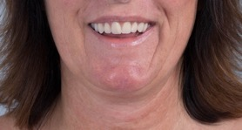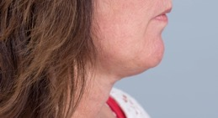

Figure 3 dentures
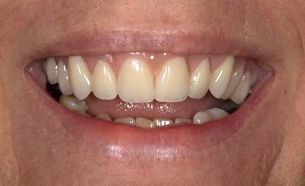

Figure 4 ridge without denture
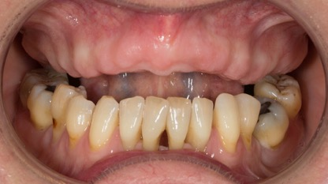

Figure 5 X ray picture of the mouth
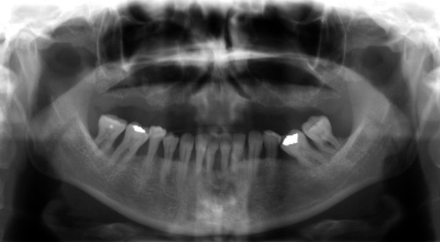
Lower teeth have had gum disease and meticulous cleaning and regular dental hygienist visits

Figures 6 and 7 – we will be able to mimic your natural teeth and make the dentures look like your natural teeth
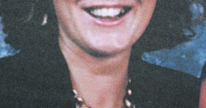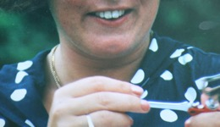

Treatment plan
Provision of a complete upper denture
Visit | Treatment and result | Time required (Hours) | Time Gap
 | Primary impressions | ½ | 2 weeks
 | Definitive impression | 1 | 2 weeks
 | Registration, discuss shade | 1 | 2 weeks
 | Try in 1 – to assess tooth position – to assess on video (with husband if wishes) | 1 | 2 weeks
 | Try in 2 – to assess on video (with husband if wishes) | 1 | 2
 | Fit | 1 | 1 week
 | Review | ½ | 2 weeks
 | 2 x more reviews
Total |  |  | 13 weeks

Figure 8 Old upper denture Figure 9 New upper denture
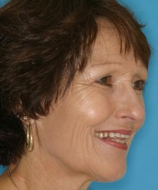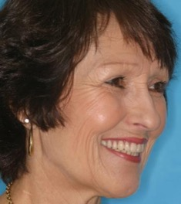

Figure 10 Before Figure 11 After
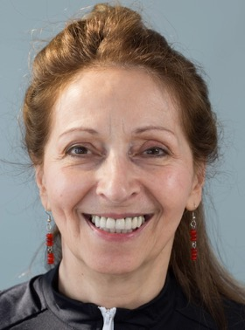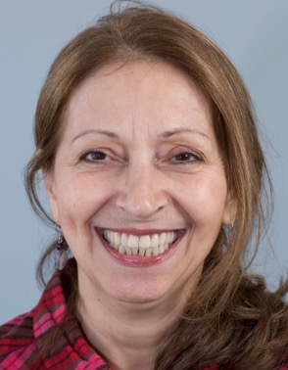

Figure 12 Before Figure 13 After
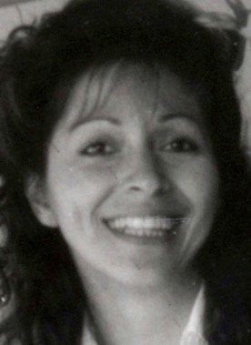

As you know, I have designed my practice around having my own in-house Dental Technologist. This means that I have complete control over the production of the laboratory work that we fabricate for our patients and is a very special part of the practice. We use the finest materials available. Mr Rowan Garstang, formerly Chief Dental Technologist at the University Dental Hospital of Manchester, will fabricate all of the restorations. He is very skilled and talented. The above photographs show the quality of the work we can achieve.

Replacing missing teeth (Prosthodontics) is challenging due to the two demands of function (chewing and eating) and aesthetics. The following list contains items that I feel you should be aware of before you decide to have treatment. It covers aspects of this type of treatment, which I feel are important and has been developed over the past 23 years following treating patients with similar requirements to you. I am confident that you will rapidly become aware of the care, attention and professionalism that we can provide for you.

I would like you to be aware of the following regarding the treatment proposal:

Dentures
- I cannot be completely sure that you have Glossodynia (burning mouth syndrome) until Rowan and I have fabricated the technically perfect denture. If the burning sensation persists after we have made the denture, I will liaise with your doctor (GP) or Mr Peter Dyer (Consultant in Oral and Maxillofacial Surgery) and Mrs Victoria Hadden (Consultant in Restorative Dentistry) and their team at RLI. Therefore I cannot guarantee that the burning sensation will be eliminated with the new denture.

- Dentures are removable mechanical substitutes for missing living tissues and as such will exhibit movement when chewing food, talking and when the tongue and muscles of the mouth move. This should improve with time as you get used to the denture.

- The new dentures will feel sore quite soon after fitting. This is normal for new denture, even when they are made to the best technical standards.

- The dentures will extend slightly further back in the mouth compared to your current denture. The extra extension is important in order to produce good suction (peripheral seal). I am confident that you will accommodate to this but you should be aware of the change prior to commencement of treatment.

- Some patients experience difficulties with speech following the fitting of new dentures. In most cases with the passage of time they are able to accommodate to this.

- Learning to chew satisfactorily with new dentures usually requires at least 6-8 weeks, and sometimes longer, particularly in complex dental situations such as you, particularly in view of the flat lower ridge and your age (which means adaptation and learning takes longer). New memory patterns must be established in order for the muscles of the tongue, cheeks and lips to keep the dentures in position.

- Initially the dentures may cause you to produce more saliva than normal. This gradually reduces over time, but you should be aware of the change prior to commencement of treatment.

- Occasionally some of our patients require denture fixative in order to keep the dentures more secure. This is a very uncommon occurrence for my patients.

- Careful handling and cleaning of the dentures is required, because they can break if dropped on to a hard surface.

- I calculate the time and appointments required as precisely as possible. I have calculated the number of appointments will include 3 reviews after the dentures have been fitted to ensure they are as confortable as possible. If further reviews are required these will be charged at £200 per review.

- Very occasionally we need to make another set of dentures after making the first one. The first set could be regarded as diagnostic set. If we need to do this I would give you an additional quotation. It is not possible to give an accurate quotation regarding a second set at this stage.

General
- Patients regularly ask how long their dentures will survive. Unfortunately, it is impossible to predict this accurately. As dentistry is not an exact science it is not possible to guarantee how long dental work will last. It is very important that you understand that Rowan and I plan and fabricate our work to the best possible standard we possibly can, using the highest quality materials along with our many years of training, experience and expertise. However, as with all things involving moving parts, things wear out, break, snap, crack etc. and will fail eventually. In addition, the mouth is a unique, dynamic environment in constant use. Due to variations in human biology, some people are heavier on their teeth than others which can lead to aspects of their dental work wearing, chipping or coming loose sooner than for those who are less heavy on their teeth. I give a warranty on the work I provide for 1 year once active treatment has finished, where problems occurring will be rectified free of charge.

- I calculate the time and appointments required as precisely as possible. However, owing to the nature of this type of dentistry additional visits may be required as necessary. If this is the case you will not be charged for the extra visits.

- Please do your best to avoid cancelling appointments. We have low number of patients, with very large overheads to run the practice and cancelled appointments have a considerable impact on our financial situation. If appointments are cancelled with less than 7 days notice for us to rebook we occasionally charge this at the full rate for the time unused. This is discretionary and we understand that occasionally this cannot be helped.

- Once the work has been provided, the work is covered under a warranty for one year. After this year further treatment for items such as repairs, refurbishment and replacement are charged at my hourly rate of £400 per hour (plus laboratory fees).

- The gums/ridges shrink slowly over time meaning that the dentures will require relining and replacement over time. My fees to reline one set of dentures at my current rate are £950.

- Once you are comfortable with the dentures, I would like to see you on a 12 monthly basis. I recommend that you see myself on an annual basis to check the dentures and the lining of the mouth. The fee for me to provide an annual review is currently £250 and will involve cleaning the dentures in a machine, designed to clean dentures – Sympro. Please contact us if you would like to have these annual reviews.

- I recommend that the dentures are replaced on a 5 yearly basis.

Professional Fees – complete upper denture

The investment for the above treatment is £5,650. In order for us to provide the highest quality specialist service, we ask for fee settlement in one of two ways as follows:

Payment in full at visit 1 of £5,650 (this is our preference)

or

- Spread payments of £5,650

First payment of £3,3,90 at visit 1
Second Payment of £1,130 at visit 3
Third payment of £1,130 at visit 5

I look forward to discussing the contents of this letter at your next visit on Wednesday.

Yours sincerely

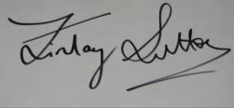

Dr Finlay Sutton

BDS, DGDP (UK), MSc, MFDS RCS Ed, MRD RCS Ed, PhD, FDS (Rest Dent) RCS Ed

Registered Specialist in Restorative Dentistry, Prosthodontics, Endodontics and Periodontics

General Dental Council Number: 69652

If you would like to go ahead with the proposed treatment, I will ask you to sign a copy of this report at prior to visit 1. By signing a copy of this report, you are confirming the following:

- That you have read the report
- That you have had the opportunity to ask and have had answered any questions about the contents of this report
- That you understand the contents of this report and agree to its terms
- That you understand and agree that the specified, agreed treatments will incur costs as discussed during the consent to treatment process
- That you agree to pay the treatment fees outlined in the report and at the timescales detailed in the report
- That if you do not keep an appointment without giving 24 hours advance notice, you must pay for the time reserved at the rate of £250 per hour
- That the practice reserves the right to charge for unused surgery time if more than 2 appointments are rearranged with less than 48 hours notice within a course of treatment
- That the practice reserves the right to suspend treatment if you fail to pay for the treatment you have had provided. If you are in default of your payment plan, the practice may use a collection agency or take legal action to secure payments, as authorised by law, and the collection action will become part of your credit record. Patients will be notified in writing before the practice takes action to collect
- Please note that your General Dental Practitioner will provide any additional treatment of your teeth, unless otherwise requested.

- Fee quotations provided in this report are valid for 6 months.

Cc Miss Victoria Hadden
Dr Michael Stainer, Unversity…

