Dear X

It was a pleasure seeing you for dental consultation today. You have been referred yourself to me for specialist removable prosthodontics (dentures).

Dental Concerns:

“Teeth are slack.”

“Every meal I take food gets under my teeth.”

Dental wish list:

“Just to keep them in place, stop food getting under. It would be fantastic.” I am sure I can help with the treatment plan below. I will be able to give you technically superb dentures being approximately 60% of the success. The other 40%, I am reliant on your adaptation (getting used to them), which gets more difficult the older you are. The new upper and lower dentures proposed in the treatment plan below will have much improved appearance.

Diagnoses/observations/findings of the mouth
- The lower ridge is very flat (highly resorbed) making it technically challenging to make good fitting dentures which will be comfortable for you to chew and function with. I am looking forward to this challenge.
- The set of dentures you showed me have many features which need to be redesigned and improved on. This means that they do not fit properly, bite properly and inhibit your function. There are many features, which I would incorporate into new dentures which I propose to make.
- The upper and lower dentures can be improved in appearance.
- The soft tissues of your mouth were visually screened for oral cancer. The soft tissues appeared healthy. This is a routine assessment I carry out for all of my patients.

Treatment options we discussed:
We discussed different treatment options for replacing the missing teeth, involving conventional dentures and lower removable dentures secured to dental implants (should there be enough bone). We considered the pros (benefits) and cons (risks) of all of these treatments. On balance you and I believe that the best option is replacement full upper and lower dentures made to the highest technical standards. As such this letter describes this option.

I consider the treatment plan set out below will give you teeth, which function better for biting and chewing and will improve on your quality of life.

Please bring in some photographs of yourself with natural teeth (as well as some of Janet’s teeth when she smiles), even if they don’t show the teeth they are useful for seeing the proper lip support face shape, and lower face height. These are very important in being able to provide the most stable and secure dentures – as they can help us position the denture teeth as closely as possible to your natural teeth.

Figure 1 Portrait Figure 2 Side view
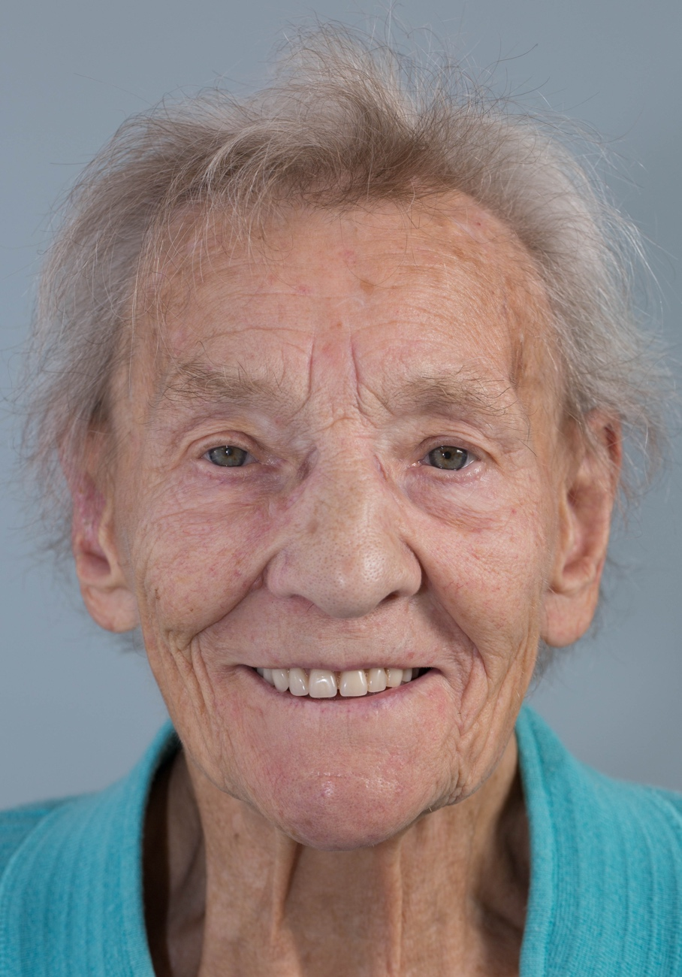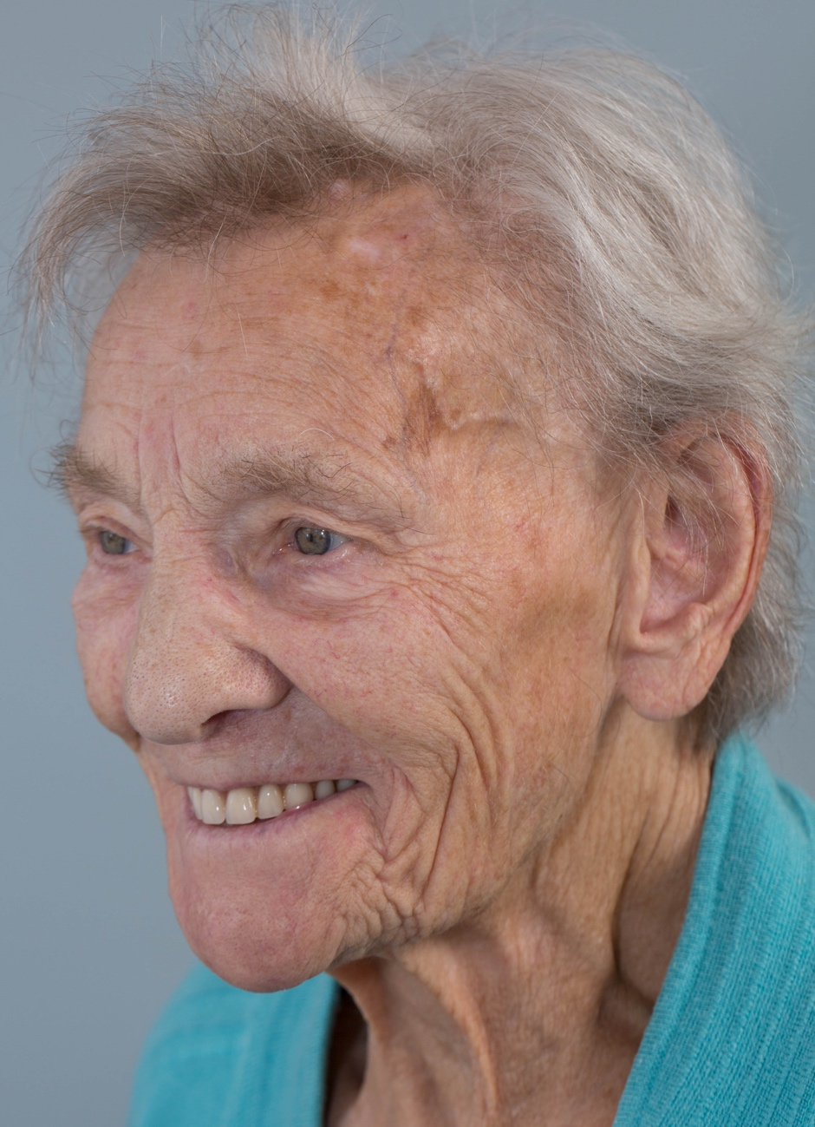

Figure 3 Smiling
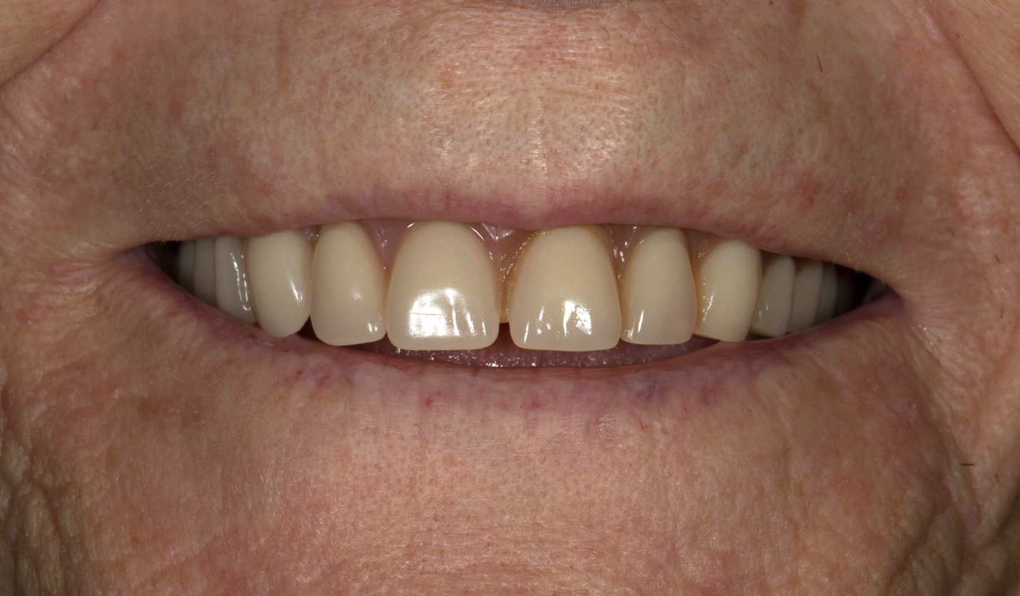

Figure 4 shallow lower ridge – difficult denture problem
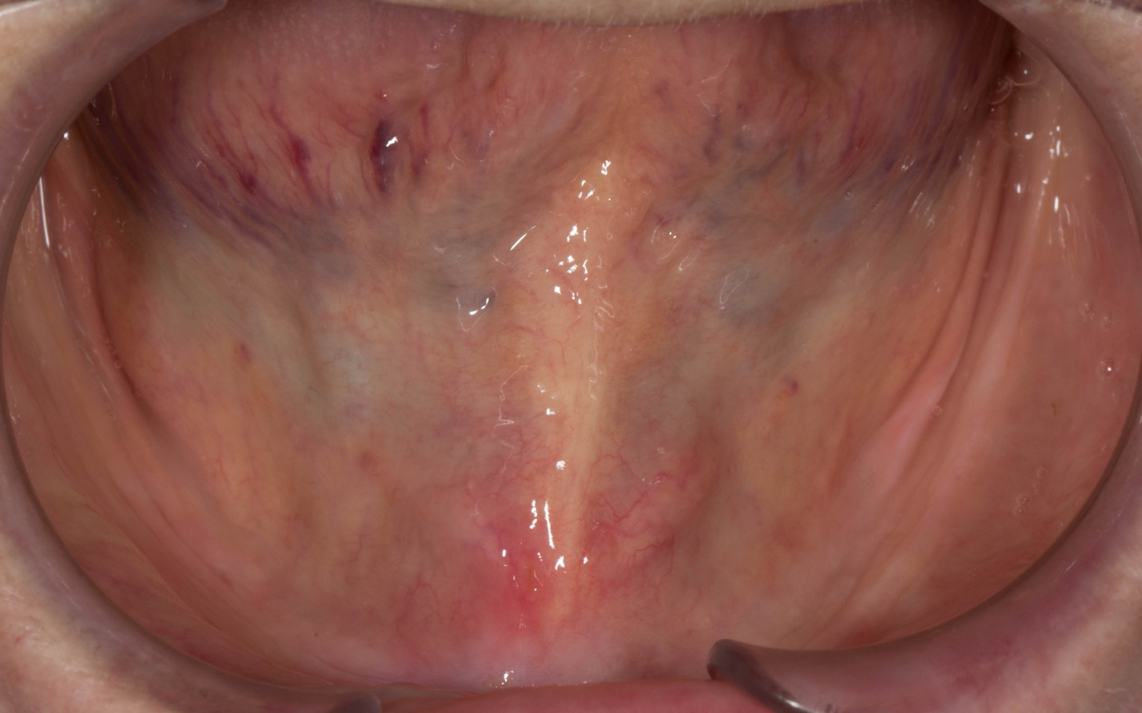

Figure 5 upper and lower complete dentures
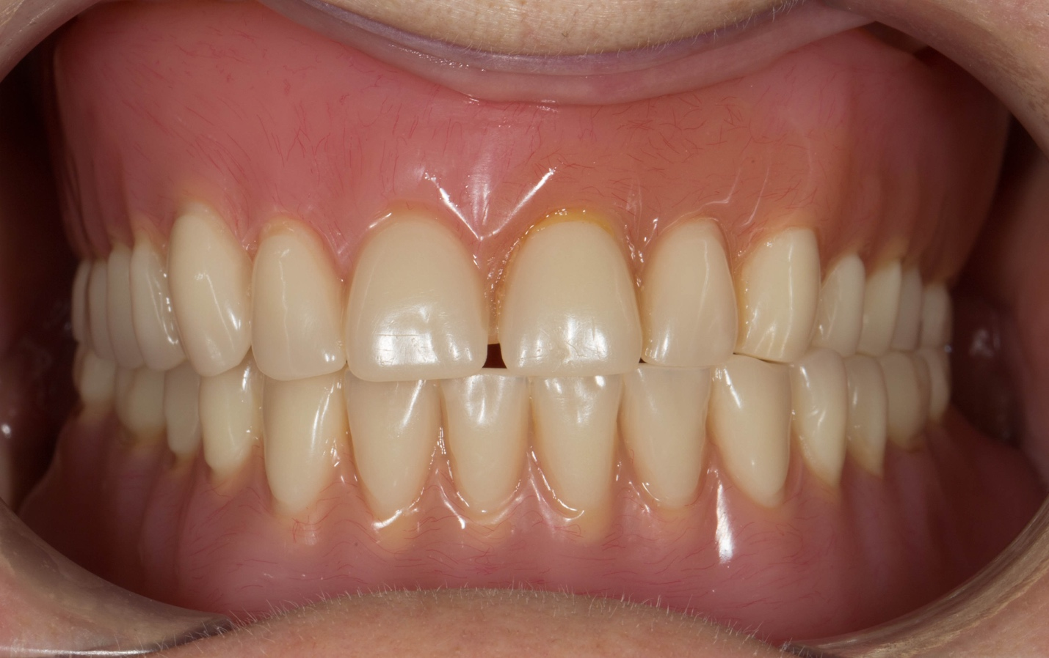

Treatment plan for complete upper and lower dentures
In summary upper and lower complete dentures will be fabricated.

Treatment visit by visit:
Visit | Treatment and result
 | Primary Impressions – photographs – look at when dentate
Definitive impressions
Primary rims
 | Registration– CBA
 | Try
 | Fit
 | Review

As you know, I have designed my practice around having my own in-house Dental Technician. This means that I have complete control over the production of the laboratory work that we fabricate for our patients and is a very special part of the practice. Rowan, formerly Chief Dental Technologist at the University Dental Hospital of Manchester, will fabricate the denture. The photographs below show two of my patients (with similar mouth condition to you) who had the same treatment outcome as I am proposing for you. Please note we can make the teeth as life and age appropriate as you wish. Our aim is to make the teeth look just like natural teeth, so that no one knows they are dentures (apart from you).

Before Now
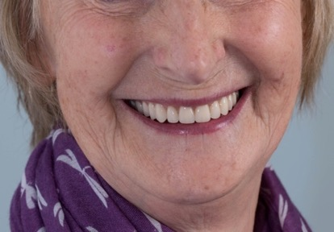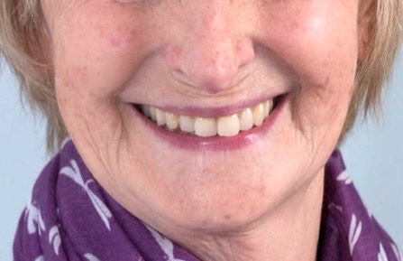

Before Now

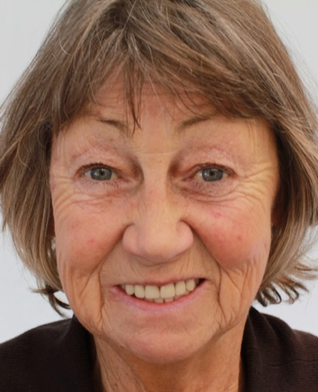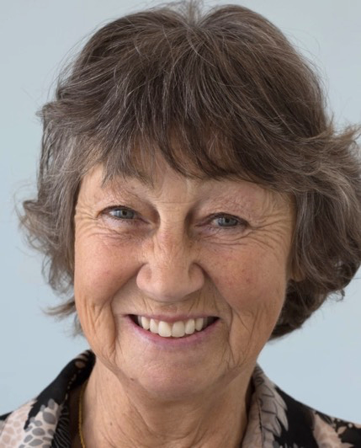

Old
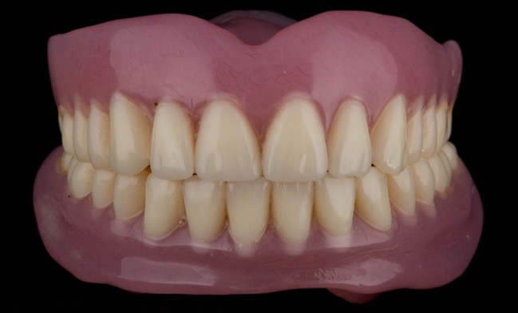

New
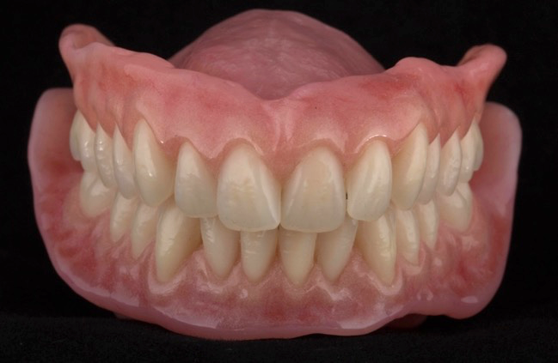

Replacing missing teeth (Prosthodontics) is challenging due to the two demands of function (chewing and eating) and aesthetics. The following list contains items that I feel you should be aware of before you decide to have treatment. It covers aspects of this type of treatment, which I feel are important and has been developed over the past 26 years following treating patients with similar requirements to you. I am confident that you will rapidly become aware of the care, attention and professionalism that we can provide for you.

I would like you to be aware of the following regarding the treatment proposal:

Dentures
- Dentures are removable mechanical substitutes for missing living tissues and as such will exhibit movement when chewing food, talking and when the tongue and muscles of the mouth move. This improves with time as you get used to the denture. The new dentures will be much more stable than your existing ones.

- The new dentures will feel sore quite soon after fitting. This is normal for new denture, even when they are made to the best technical standards. This is why review appointments are necessary to adjust them. For you, I estimate 3 reviews may be necessary, owing to the flat ridges.

- The dentures will extend further back in the mouth compared to your current denture. The extra extension is important in order to produce good suction (peripheral seal). I am confident that you will accommodate to this but you should be aware of the change prior to commencement of treatment.

- Some patients experience speech changes following the fitting of new dentures. In most cases with the passage of time they are able to accommodate to this.

- Learning to chew satisfactorily with new dentures usually requires at least 6-8 weeks, and sometimes up to 6 months, particularly in complex dental situations such as you, particularly in view of the flat ridges. New memory patterns (neuromuscular control) must be established in order for the muscles of the tongue, cheeks and lips to keep the dentures in position.

- Initially the dentures may cause you to produce more saliva than normal. This reduces over time.

- Occasionally some of our patients require denture fixative in order to keep the dentures more secure and prevent food from findings its way underneath. This is quite an uncommon occurrence for my patients but is sometimes needed.

- Careful handling and cleaning of the dentures is required, because they can break if dropped on to a hard surface.

- It is important that the new lower denture we provide will fit and feel better than the one you currently have. We will make it to the best possible standard using all of our skills and knowledge, giving you the best possible chance of being able to wear it comfortably. We are, however, reliant on your adaptation to the denture and it will require considerable practice and effort on your behalf to make it work. A similar analogy is learning how to use chopsticks instead of a knife and fork. In the event the new lower denture is unsatisfactory for you, we will need to consider a more complex option to support the denture – i.e. dental implants. If after the above treatment you feel that you need a more stable or comfortable lower denture we can consider placement of 2 dental implants, which will stabilise the denture. This is dependant upon enough bone being present for placing the implants. A CT scan would be required to assess this. The additional fee for two dental implants securing the lower denture would be approximately £9,000.

General
- Patients regularly ask how long their dentures will survive. Unfortunately, it is impossible to predict this accurately. As dentistry is not an exact science it is not possible to guarantee how long dental work will last. It is very important that you understand that Rowan and I plan and fabricate our work to the best possible standard we possibly can, using the highest quality materials along with our many years of training, experience and expertise. However, as with all things involving moving parts, things wear out, break, snap, crack etc. and will fail eventually. In addition, the mouth is a unique, dynamic environment in constant use. Due to variations in human biology, some people are heavier on their teeth than others which can lead to aspects of their dental work wearing, chipping or coming loose sooner than for those who are less heavy on their teeth. I give a warranty on the work I provide for 1 year once active treatment has finished, where problems occurring will be rectified free of charge.

- I calculate the time and appointments required as precisely as possible. However, owing to the nature of this type of dentistry additional visits may be required as necessary. If this is the case you will not be charged for the extra visits.

- Once the work has been provided, the work is covered under a warranty for one year. After this year further treatment for items such as repairs, refurbishment and replacement are charged at my hourly rate of £425 per hour (plus laboratory fees).

- I generally recommend that the dentures are replaced on a 5 yearly basis.

Professional Fees – complete dentures:

The investment for the above treatment is £5,200. This is with a discount of £1,300 as the normal cost for dentures of this degree of difficulty would be £6,500. In order for us to provide the highest quality specialist service, we ask for fee settlement in one of two ways as follows:

Payment in full at visit 1 of £5,200

or

- Spread payments of £5,200

First payment of £3,120 at visit 1
Second Payment of £1,040 at visit 2
Third payment of £1,040 at visit 3

I understand that the level of investment for this treatment is high. However, in order to do this treatment properly and give you a good functional/aesthetic result requires considerable clinical expertise, laboratory expertise, clinical time and laboratory workshop time using expensive materials.

I would ask you to kindly sign the bottom of each page acknowledging that you have read, understood and agree to the terms of this letter and return in the SAE provided and Claire (my dental nurse) will organise your appointments.

Yours sincerely

Dr Finlay Sutton

BDS, DGDP (UK), MSc, MFDS RCS Ed, MRD RCS Ed, PhD, FDS (Rest Dent) RCS Ed

Registered Specialist in Restorative Dentistry, Prosthodontics, Endodontics and Periodontics

General Dental Council Number: 69652

If you would like to go ahead with the proposed treatment, I will ask you to sign a copy of this report at prior to visit 1. By signing a copy of this report, you are confirming the following:

- That you have read the report
- That you have had the opportunity to ask and have had answered any questions about the contents of this report
- That you understand the contents of this report and agree to its terms
- That you understand and agree that the specified, agreed treatments will incur costs as discussed during the consent to treatment process
- That you agree to pay the treatment fees outlined in the report and at the timescales detailed in the report
- Fee quotations provided in this report are valid for 6 months.

