Dear

It was a pleasure seeing you accompanied with Ben for dental consultation last week.

Dental Concern:
“I have never had a bad tooth. They have just fallen out over 9 years.”

Dental wish list
“I am a singing teacher as this is part of my teaching I would like to feel confident to continue singing.”

Diagnoses:
- There are missing teeth in the upper and lower parts of the mouth. I propose replacing these with immediate acrylic based partial dentures in the first phase and cobalt chromium based partial dentures in the second phase of the treatment plan below.
- The following eight teeth are not saveable the UR6, 4, 3, the LR5, 1, LL1, 2, 3. I propose replacing these with immediate acrylic based partial dentures in the first phase and cobalt chromium based partial dentures in the second phase of the treatment plan below.
- The remaining eight teeth are in slightly better condition but owing to the gum disease it is not fully possible to predict when these teeth may fail. I have designed the treatment plan below involving cobalt chromium based dentures to help reduce the forces on these teeth. In addition, should one or more of the teeth be lost, teeth can be added onto the partial denture. Should many of these teeth fail the dentures proposed will become redundant. If this occurs a new treatment plan will be required.
- The remaining 8 teeth which I propose keeping have a better prognosis if the gum disease is treated. I recommend that the gum disease is managed during the 9 – 12-month healing phase by my colleague Mr Syed Abad, Specialist in Periodontics. He will offer you a treatment plan and quotation (probably £1,600 for a course of therapy). A consultation with Syed will be arranged for you after the immediate dentures have been fitted.
- The soft tissues of your mouth were visually screened for oral cancer. The soft tissues appeared healthy. This is a routine assessment I carry out for all of my patients.

Options discussed for replacing the missing upper teeth.

Do nothing

You did not want this.

Cobalt chromium based upper and lower partial dentures:
We discussed this as an option for replacing the missing upper and lower teeth. Although partial dentures are not as rigid and solid in the mouth for chewing and eating compared with dental implant supported teeth, well designed and well-made partial dentures, as I propose, will improve your chewing function. A very important aspect of the design of these is that they will help protect the fragile teeth and in the event of one of the natural teeth failing, a tooth may be added onto the partial denture.

Dental implant supported teeth:

I do not believe that dental implants are in your best interest, as they are likely to be affected by a disease which is similar to gum disease. This should option should only be explored if the proposed plan – option 3 fails.

Figure 1 Figure 2 beautiful smile

Figure 3 smiling
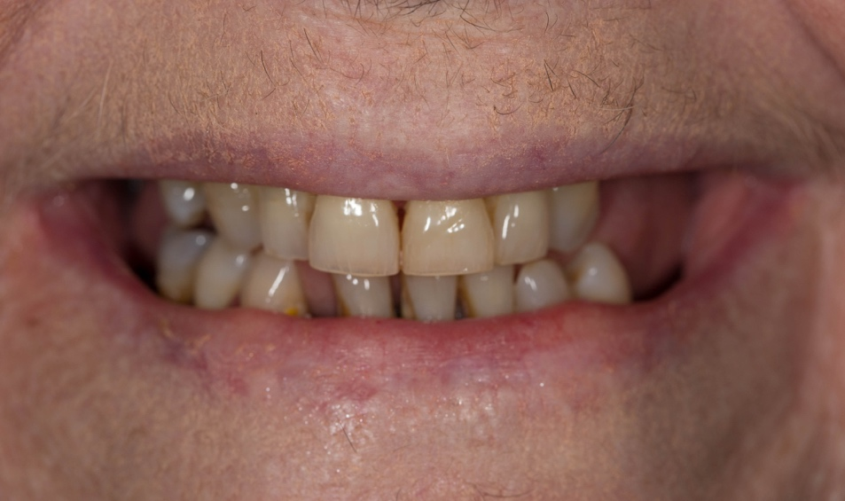

Figure 4 teeth with lips retracted
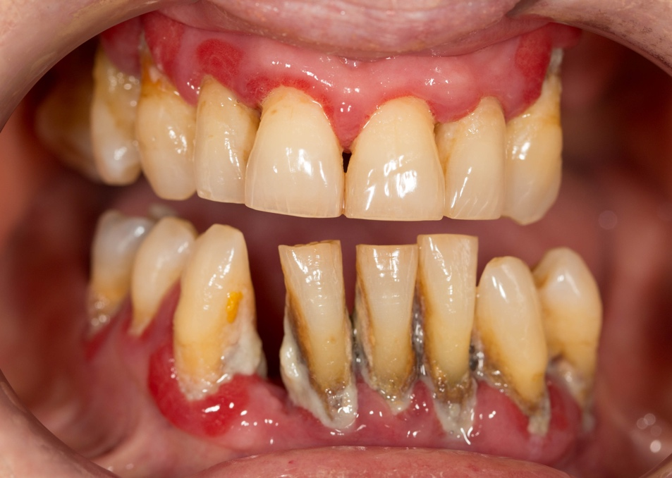
8 teeth to be removed. These and the remaining missing teeth will have their teeth replaced as per the treatment plan below.

Figure 5 upper teeth
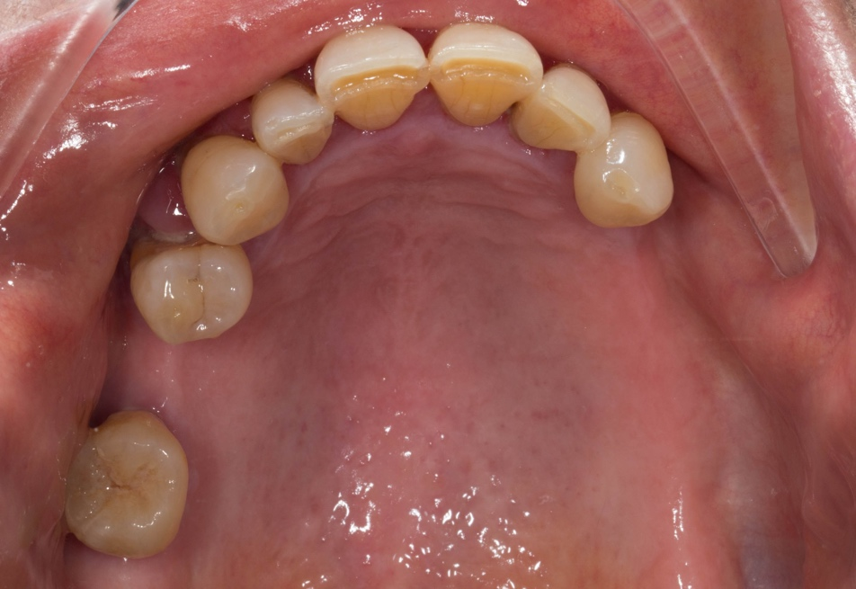
In the upper jaw 3 teeth to be removed. These and the remaining missing teeth will have their teeth replaced as per the treatment plan below.

Figure 6 lower teeth
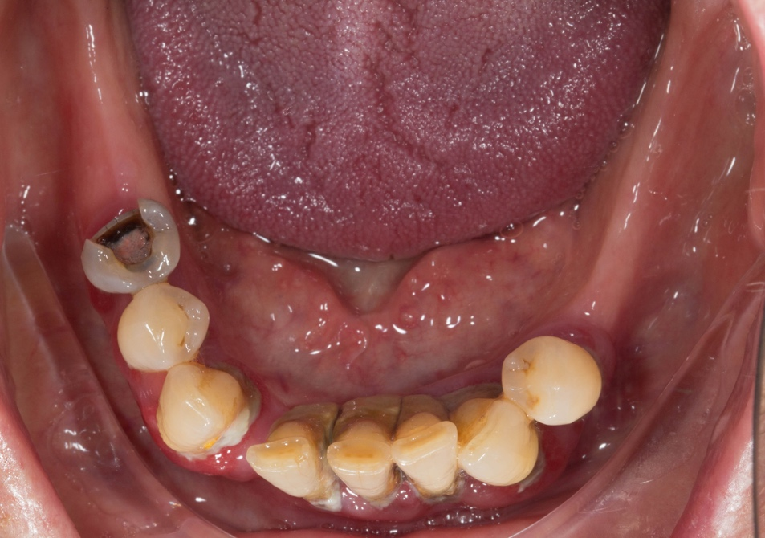
In the upper jaw 5 teeth to be removed. These and the remaining missing teeth will have their teeth replaced as per the treatment plan below.

Figure 7 X- ray picture of the teeth
8 teeth to be removed. These and the remaining missing teeth will have their teeth replaced as per the treatment plan below.
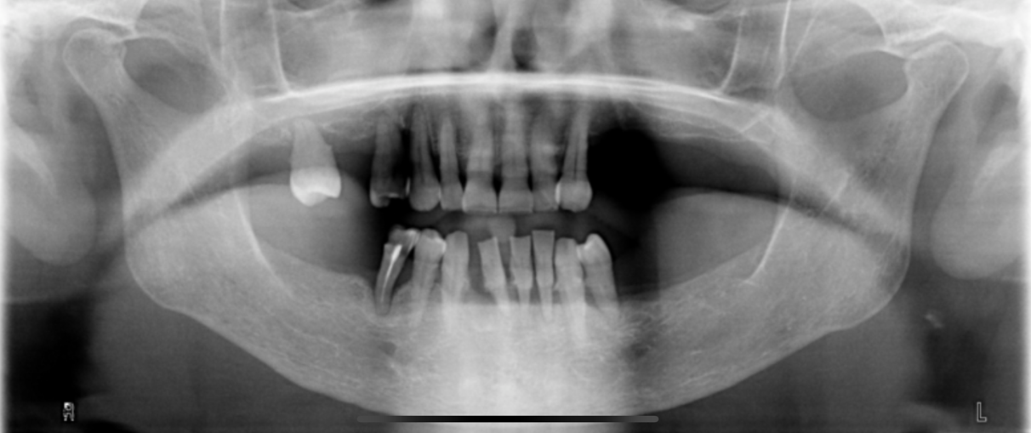

Treatment plan
Objective:
- Extract UR6, 4, 3, the LR5, 1, LL1, 2, 3
- Immediate acrylic based dentures - complete upper and lower partial
- Periodontal therapy – Mr Syed Abad to be arranged after visit 3 with Fin– very important £1,600
- Reviews of the dentures and relines as necessary over 9 months
- Definitive dentures – complete upper and lower cobalt chromium based partial

Treatment plan step by step
Visit | Treatment and result
Consent
Primary impressions
Make sure periodontal treatment organised for lower teeth – after appointment 3
 | Registration
Extract UR6, 4, 3, the LR5, 1, LL1, 2, 3
Fit Immediate acrylic based upper and lower partial

Reviews and relines over 9 – 12 months as needed
Periodontal treatment to be provided by Syed during this time

 | Primary impressions
Scaling and polishing teeth
Composite placement under rubber dam on anterior teeth
Definitive impressions
 | Rims at ICP
 | Try in – teeth only
 | Try chromes
 | Fit
 | Review

I will review you until you are as comfortable as possible. Occasionally this takes up to 3 review visits. This is included in the treatment plan and quotation.

As you know, I have designed my practice around having my own in-house dental technician, Rowan Garstang. This means that I have complete control over the production of the laboratory work that we fabricate for our patients and is a very special part of the practice. We use the finest materials available. I regard Rowan as one of the finest dental technicians in the UK and his work is incredible. Rowan will make the denture.

Figure 8 Patient without upper cobalt chromium based denture
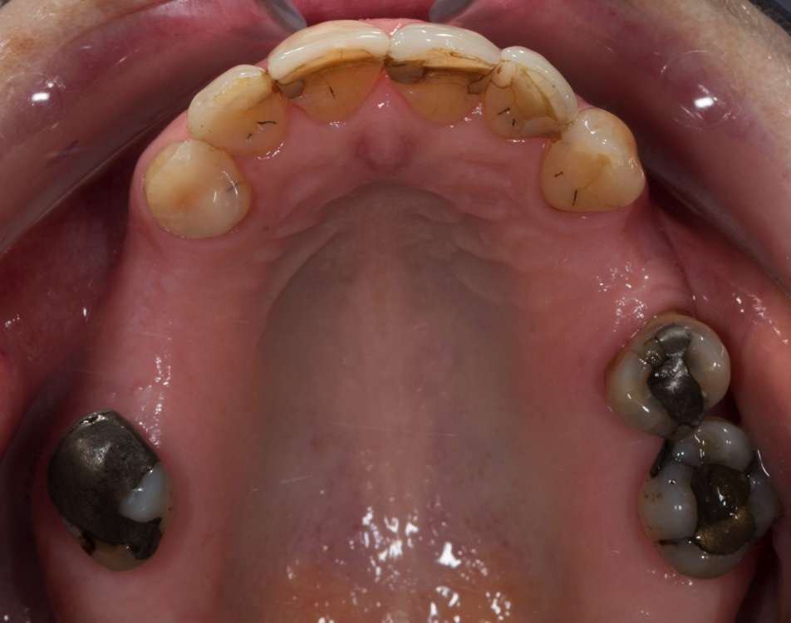

Figure 9 an example of a denture similar in shape to the upper one I propose for you. The patient with this denture is very happy indeed with their denture.
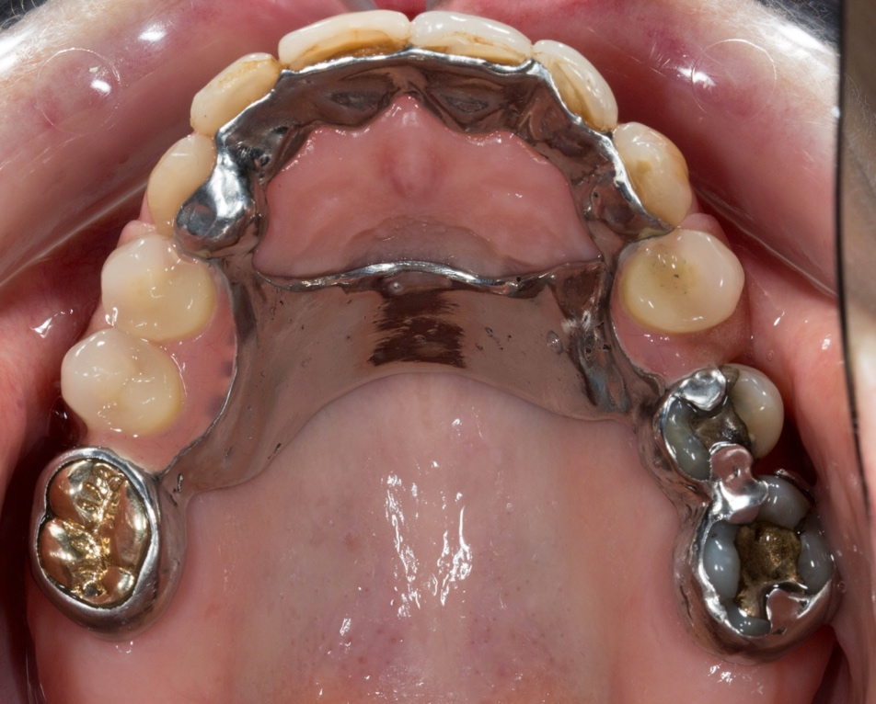
This area of the palate is kept completely free. The only area where the denture touches on the inside of the teeth facing the inside of the mouth
This is the strap that will cross the palate.
The upper front teeth are protected by the denture at the front and can be added to when the teeth fail

Figure 10 an example of a denture similar in shape to the upper one I propose for you. The patient with this denture is very happy indeed with their denture.
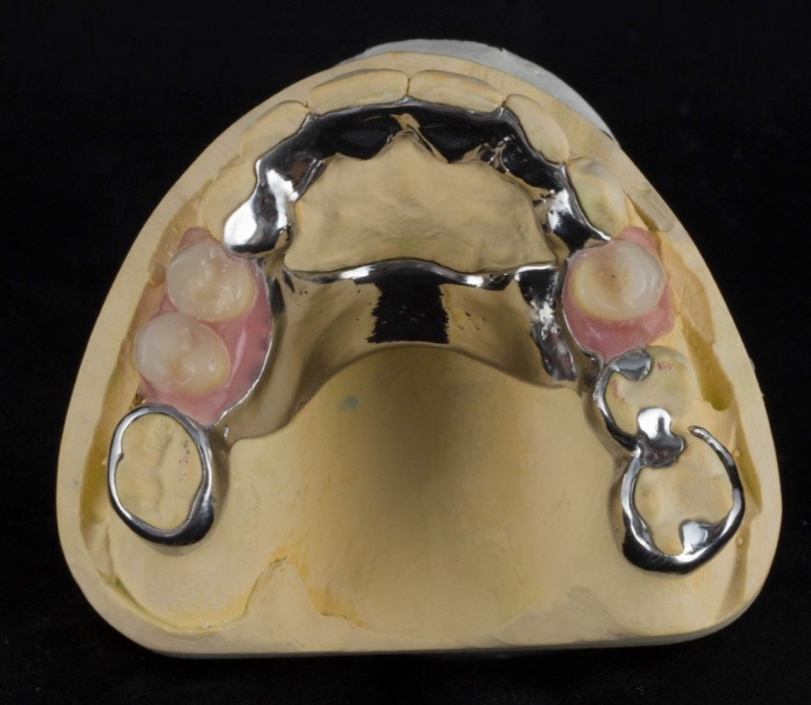
This area of the palate is kept completely free. The only area where the denture touches on the inside of the teeth facing the inside of the mouth
This is the strap that will cross the palate. This will be thinner than the one shown here.
The upper front teeth are protected by the denture at the front and can be added to when the teeth fail

Figure 11 my patient with this type of denture. She is very happy indeed with her denture.

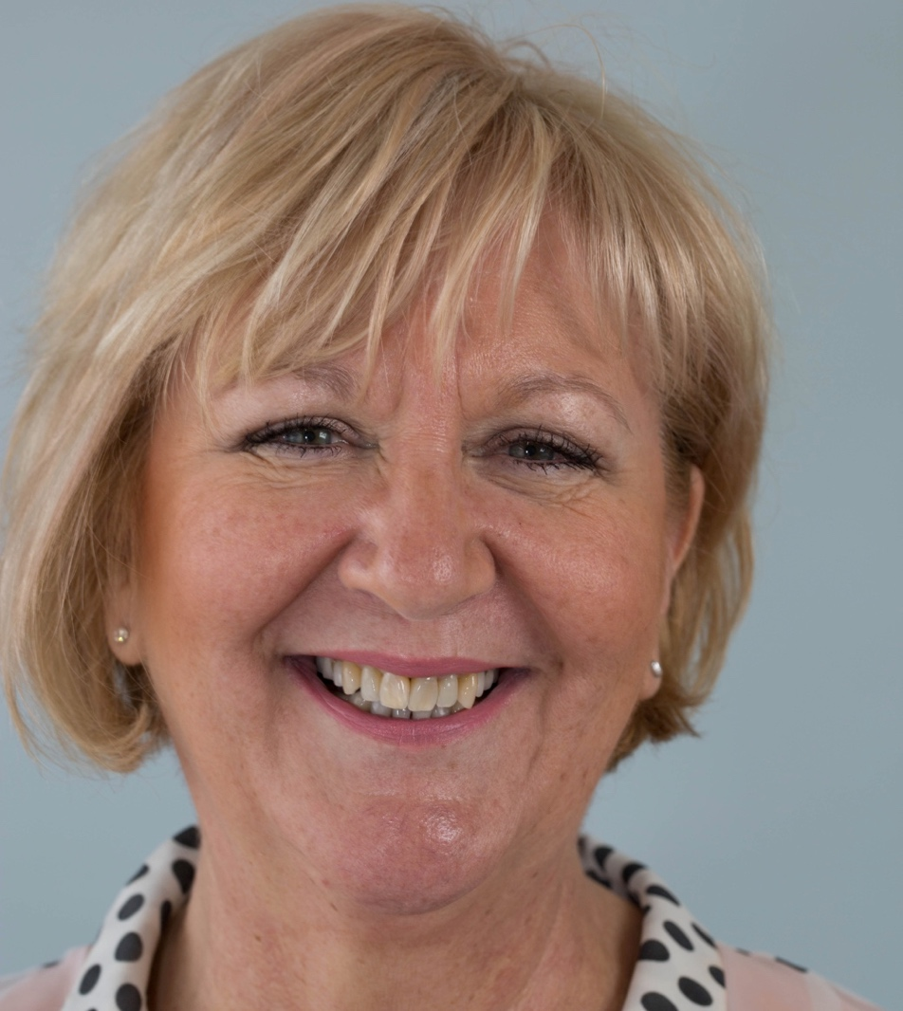

Figure 12 example of a lower cobalt chromium based lower partial denture on a model
Without lower teeth
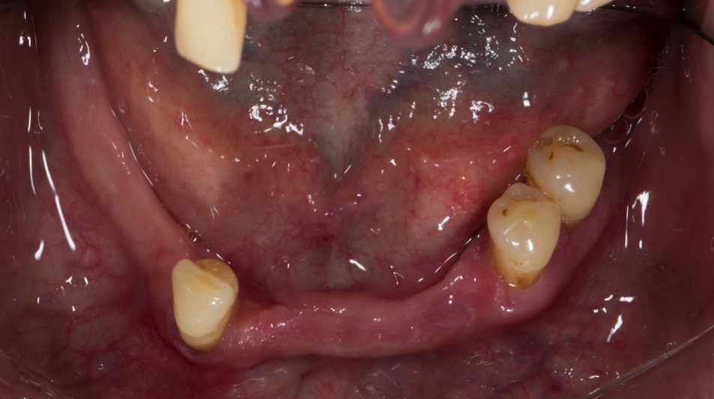

Figure 13 New lower teeth fitted
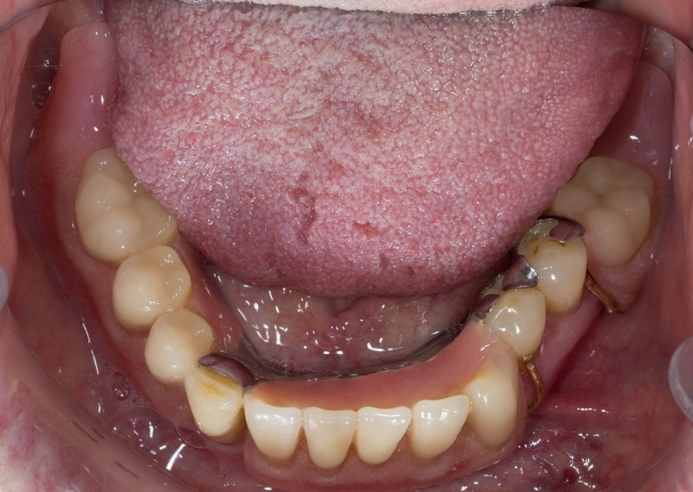

Figure 14 your definitive denture designs
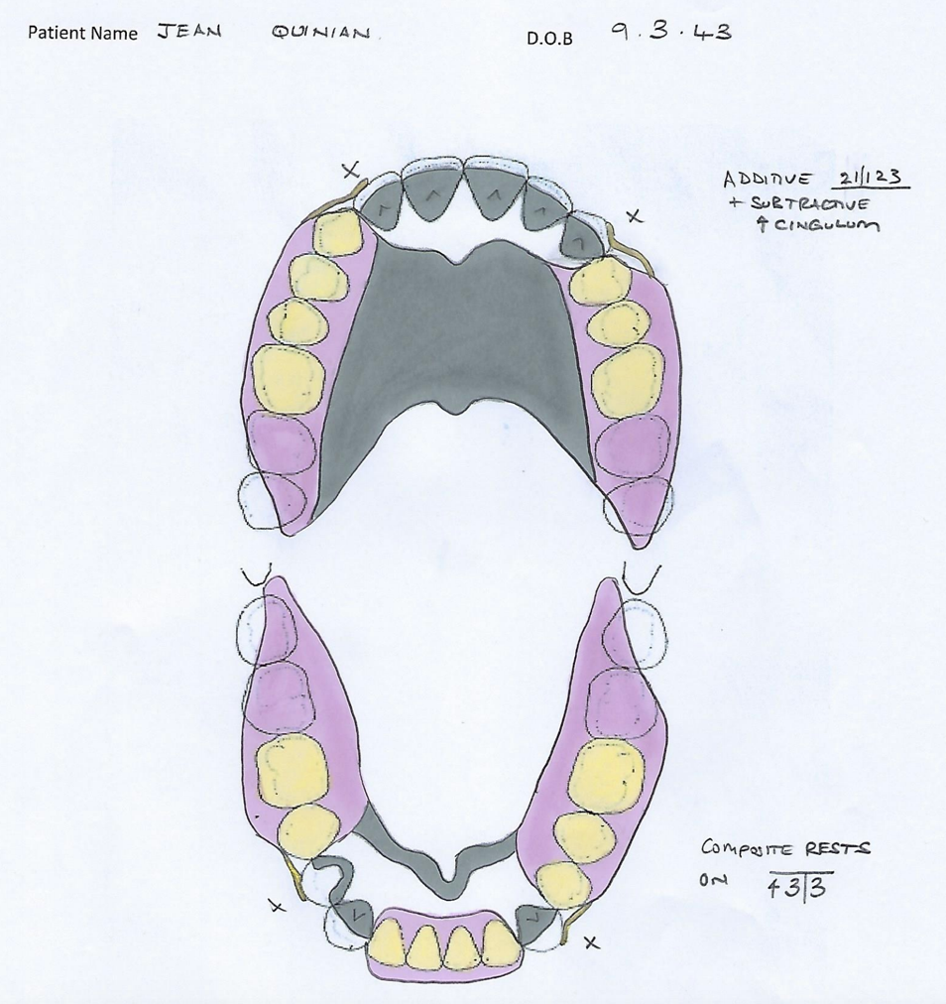

Rowan, the team and I do our absolute best to ensure that all treatment we deliver is successful. I would like you to be aware of the following regarding the treatment proposed:

It is impossible to know how long the rest of your natural teeth will survive. It is important to limit your consumption of sugar in the diet to a minimum and keep your teeth meticulously clean with brushing and interdental brushes every day.

I would like you to be aware of the following:

Temporary dentures
The dentures are fitted immediately after extraction of the teeth, as such they do not fit perfectly onto the gums.

I normally advise having a minimum of 1 week off work (ideally 2 weeks) after having the teeth extracted and the dentures fitted – (visit 2), as the mouth will be sore after the extractions. When we discussed this you still wish to continue work.

Interim dentures are removable mechanical substitutes for missing living tissues and as such exhibit some movement when in the mouth and when chewing food.

Some patients experience changes with speech and singing following the fitting of a new denture. In most cases my patients adapt to this without too many problems.

Learning to bite (incise) and chew (masticate) satisfactorily with interim denture usually requires at least 6-8 weeks and can occasionally take up to 1 year to fully adapt. The bite is designed so that the front upper and lower teeth do not contact when the back teeth bite together. This makes the dentures more stable and less likely to tip when biting and chewing food. Adapting to this takes time and memory patterns must be established in order for the muscles of the tongue, cheeks and lips to keep the dentures in position.

Some patients require denture fixative in order to keep their interim dentures more secure.

Careful handling and cleaning of the denture is required because they can break if dropped on to a hard surface.

The interim dentures will require replacement after 9 months with definitive cobalt chromium based dentures. They are not a long-term solution to these missing teeth.

Cobalt chromium based dentures
Careful handling and cleaning of the dentures are required, because they can break if dropped on to a hard surface.

Dentures are removable mechanical substitutes for missing living tissues and as such will always exhibit a small amount of movement when in the mouth, mainly when chewing food and eating sticky food. I believe that you will adapt to this.

Rowan and I have designed the dentures in such a way that helps to protect the remaining natural teeth, so that they last for as long as possible. However, in the event that a tooth is lost, the dentures will be designed in such a way that allows an addition to the denture. If many teeth are lost in the future this may mean that the dentures are not useable and we need to come up with a new strategy – probably complete dentures.

The dentures will be retained by a cast cobalt chromium clasps on the teeth. The clasps will not damage the teeth when the denture is taken in and out. The dentures will be designed with a very specific path of insertion and withdrawal and as such the amount of “grip” required from the clasps will be minimal. I will teach you how to do take them in and out safely. These clasps and some of the metal work may be slightly visible when you smile broadly. I do not feel that this will detract from your smile.

Some of the natural teeth will require a small amount of grinding, to allow the dentures to sit optimally. This does not damage the teeth.

Learning to speak and sing with dentures may take between 8 weeks and 6 months to fully adapt. Please note that our patients have always adapted to them and their speech and singling normalises with time.

Learning to chew satisfactorily with a denture usually requires at least 6-8 weeks, and occasionally a little longer.

Food may find its way underneath the dentures during eating. The dentures will be designed in such a way to minimise this however as dentures are removable this may occur.

General
Patients regularly ask how long their teeth, fillings and dentures will survive. Unfortunately, this is impossible to predict. As dentistry is not an exact science I cannot guarantee how long the work we provide will last. It is very important to understand that Rowan and I fabricate everything to the best possible standard we possibly can, using the highest quality materials and along with our expertise. However, as with all things involving moving parts, things wear out, break, snap, crack etc. and will fail eventually. I give a warranty on the work for 1 year once active treatment has finished, where problems occurring will be rectified free of charge. I cannot predict how long the restorations we provide will last. However, because everyone’s mouth is unique and some people are heavier than others on their teeth. I cannot be absolutely definite about this.

The definitive dentures will be retained and supported by the eight natural teeth. As such it is important to keep these natural teeth scrupulously clean, particularly around the gum line, in order to reduce the potential for gum disease and tooth decay. Mr Syed Abad (consultation and quotation required for this – likely to be £1,600 for a course of treatment – not included in the treatment plan below).

I have spent many years working in dental hospitals, doing further training. All of my qualifications and training have been gained with the sole purpose of giving my patients the very best treatment available. Rowan was the chief prosthodontic (head) technician at Manchester Dental Hospital for 10 years. We have both worked together and have been involved in treating patients with extremely complex restorative needs since 1999. I have designed my practice around having my own in-house dental technician. This means that I have complete control over the production of the laboratory work that we fabricate for our patients and is a very special part of the practice.

It is always at the forefront of my mind when treating my patients that they are investing considerable amounts of money having their mouths restored. As such I do my very best for everybody, using my expertise, experience and training. I treat all of my patients in a way I would like to be treated, recommending treatment, which I believe, is appropriate for each individual.

Once the work has been provided, the work is covered under a warranty for one year. After this year further treatment for items such as repairs, refurbishment and replacement are charged at my hourly rate of £450 per hour (plus materials).

Professional fees for the above plan:

The investment for this treatment is £16,000. In order for us to provide the highest quality specialist service, we ask for fee settlement in one of two ways as follows:

Payment in full at visit 1 £16,000

or

- Spread payments of £16,000

First payment of £9,600 at visit 1
Second Payment of £3,200 at visit 3
Third payment of £3,200 at visit 4

I understand that the level of investment is high. However, in order to do this treatment properly and giving you a good result requires considerable clinical and laboratory workshop time, our expertise and the use of expensive materials and components.

As you wish to proceed with the above treatment, would you kindly sign the bottom of each page acknowledging that you have read, understood and agree to the terms of this letter and return one copy of this letter to visit 1 on 18th December 2019 at 8.30am.

Rowan, Claire the team and I will be delighted to help you achieve your wishes.

With best wishes

Yours sincerely

Dr Finlay Sutton

BDS, DGDP (UK), MSc, MFDS RCS Ed, MRD RCS Ed, PhD, FDS (Rest Dent) RCS Ed

Registered Specialist in Restorative Dentistry, Prosthodontics, Endodontics and Periodontics

General Dental Council Number: 69652

If you would like to go ahead with the proposed treatment, I will ask you to sign a copy of this report at visit 1. By signing a copy of this report, you are confirming the following:

- That you have read the report
- That you have had the opportunity to ask and have had answered any questions about the contents of this report
- That you understand the contents of this report and agree to its terms
- That you understand and agree that the specified, agreed treatments will incur costs as discussed during the consent to treatment process
- That you agree to pay the treatment fees outlined in the report and at the timescales detailed in the report
- That if you do not keep an appointment without giving 24 hours advance notice, you must pay for the time reserved at the rate of £250 per hour
- That the practice reserves the right to charge for unused surgery time if more than 2 appointments are rearranged with less than 48 hours notice within a course of treatment
- That the practice reserves the right to suspend treatment if you fail to pay for the treatment you have had provided. If you are in default of your payment plan, the practice may use a collection agency or take legal action to secure payments, as authorised by law, and the collection action will become part of your credit record. Patients will be notified in writing before the practice takes action to collect
- Please note that your General Dental Practitioner will provide any additional treatment of your teeth, unless otherwise requested.

- Fee quotations provided in this report are valid for 6 months.

