Dear

It was lovely to see you for consultation last week. Dr X has referred you to me for specialist prosthodontics.

Your dental concern/problem:
- “Loose teeth.”
- “Plates upper and lower.”
- “Bridge UR quadrant – doesn’t feel right.”

You would like the following:
- “Don’t want implants.”
- Would like nice white teeth.”

I have examined each tooth clinically and radiographically

Diagnoses (Findings):
- The upper and lower natural teeth which support bridgework are in poor condition. There is severe gum disease affecting these teeth. It may be possible to save some of the teeth, but there is a strong possibility that they would cause problems in the future. We both agreed that the best course of action is to replace all of your teeth with complete upper and lower dentures. This is set out in the treatment plan below.
- The soft tissues of the mouth appear healthy. This is a routine examination I provide checking the soft tissues of the mouth for oral cancer.

We discussed a number of options for resolution of the dental problems namely:
- Replacement teeth with conventional dentures following extraction of the remaining teeth. This process would involve provision of immediate/interim dentures fitted at the extraction appointment. These interim dentures would be worn for 12 months until the gums shrink to a stable position. Definitive dentures would then be fabricated. This option has the advantages that there is no surgery for dental implants and it will produce a superb aesthetic outcome (a really nice smile). The main disadvantage is that it is removable. This is the option we both felt was the most appropriate and the treatment plan is described below. We can always go to the dental implant options later if you wanted extra stability of the dentures for biting and chewing. This would need to be considered within 6 months of fitting the definitive dentures. I do not believe this would be necessary as you have developed good control of less than perfect dentures.
- As option 1 with the added benefit of the lower denture being supported by two dental implants. To be considered 6 months after fitting the definitive dentures (additional £9,000)
- Dental implants in the lower jaw (if there is enough bone present) to secure a fixed bridge to with conventional upper complete denture. (£30,000)
- Dental implants in the upper and lower jaw to secure fixed bridges to (if there is enough bone present) (£50,000)

Figure 1 Portrait Figure 2 on the angle

Figure 3 teeth smiling
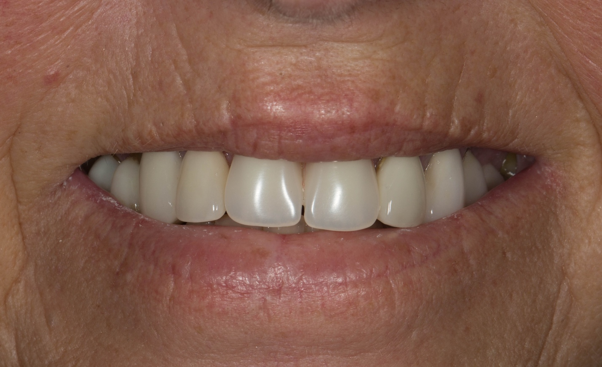

Figure 4 teeth with lips apart – teeth with poor prognosis
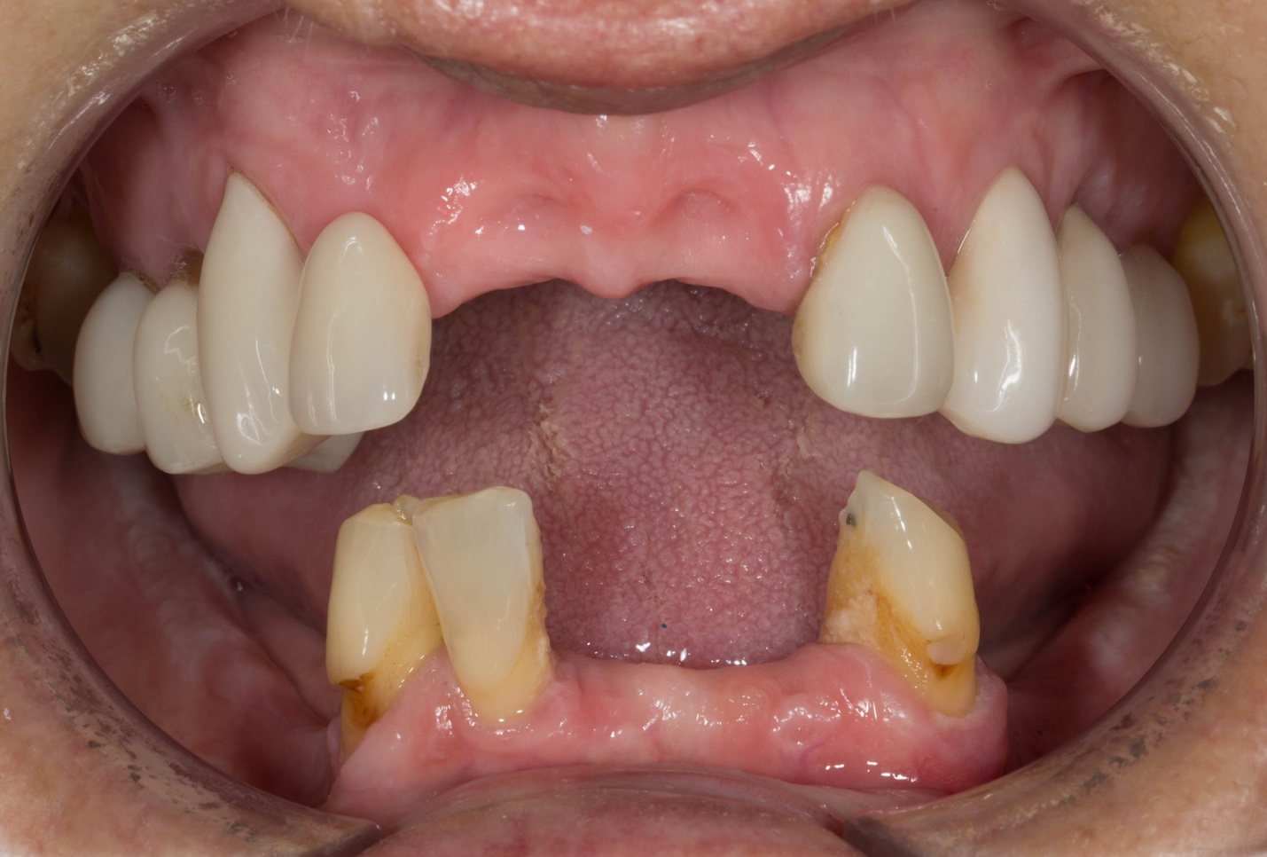

Figure 5 (a-f) X ray pictures showing teeth with poor prognosis
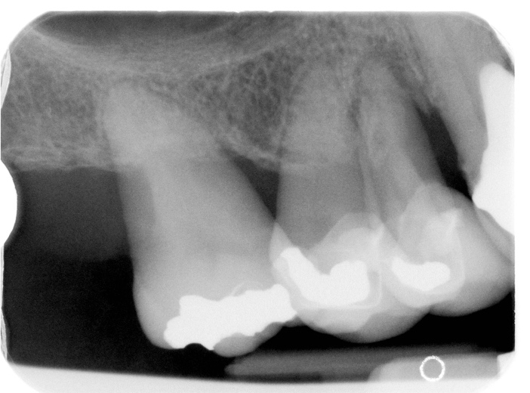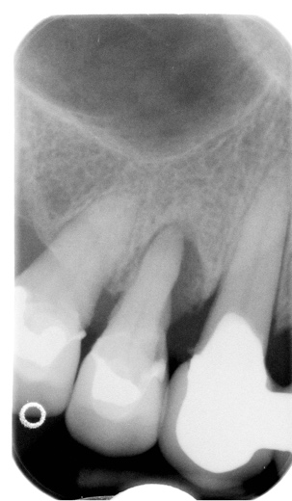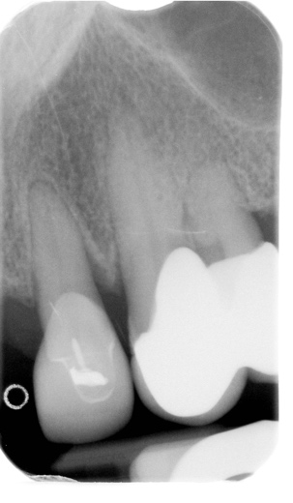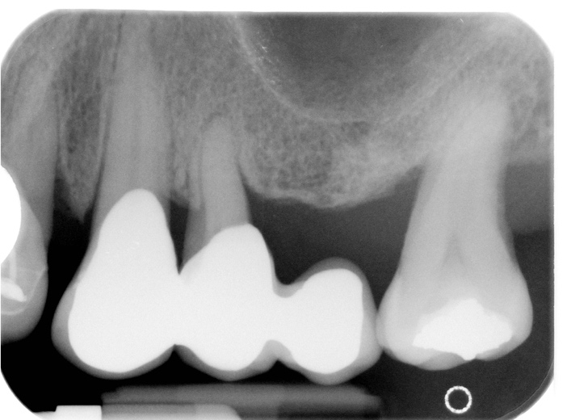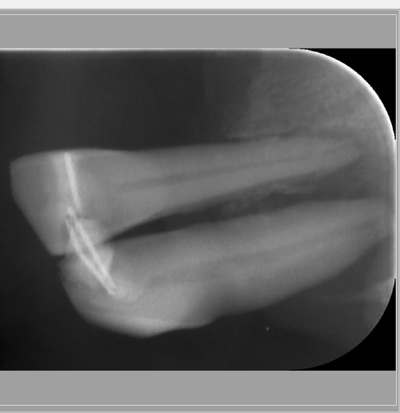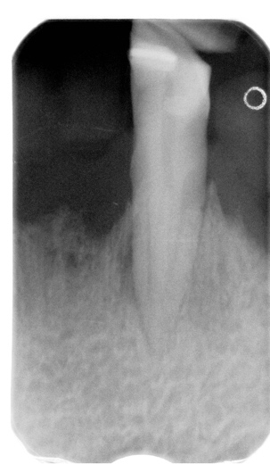

Treatment plan
In summary, the remaining natural teeth will be removed and replaced with complete dentures. You will be given two sets of dentures. The first set of dentures are immediate interim dentures, which are fitted straight after extracting the teeth. At no stage would you be without teeth. The interim denture is reviewed on a regular basis for approximately 9 - 12 months, until the definitive dentures are constructed.

The immediate dentures will have good aesthetics and will improve on your current dental situation considerably. However, the definitive dentures (metal based – reinforced to make them more robust), which will be made and fitted twelve months after extracting the remaining teeth, will have excellent aesthetics, fit correctly and will be more comfortable. They may still require fixative to use.

Treatment plan in detail step by step:
Visit | Treatment and result
 | Primary imps - compo alginate
 | Definitive impressions 2 part
 | Extract all natural teeth (re-contour bone as needed) and fit immediate complete dentures
Reviews over 9 - 12 months as necessary (may require 6-8 additional visits)
Primary impressions needed
 | Definitive - impression – for definitive upper and lower dentures
 | Registration stage
 | Trial insertion
 | Fit dentures
Review
(reline imp immediate dentures)
 | Review and fit immediate dentures

The photographs show some of my patients who have had this treatment provided.

Example of a new immediate interim denture made recently for my patient

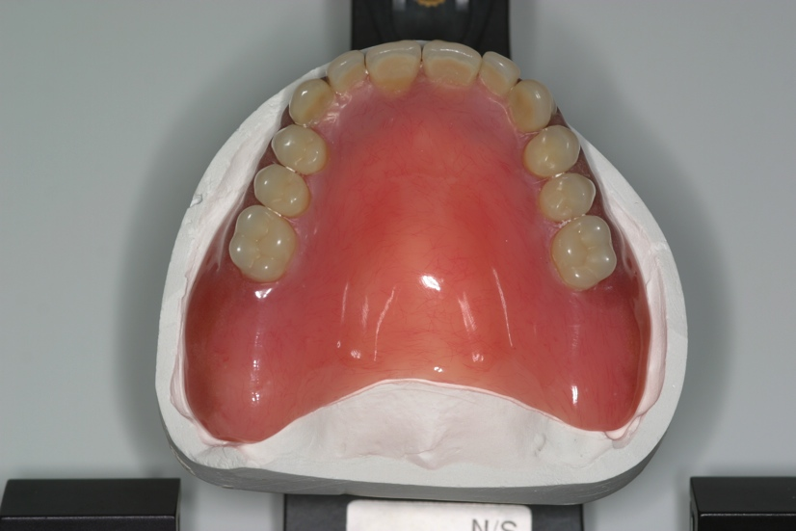
This is the amount of extension necessary for the denture in order to give it the best suction– most patients adapt to this very well

Before – with crowned natural teeth
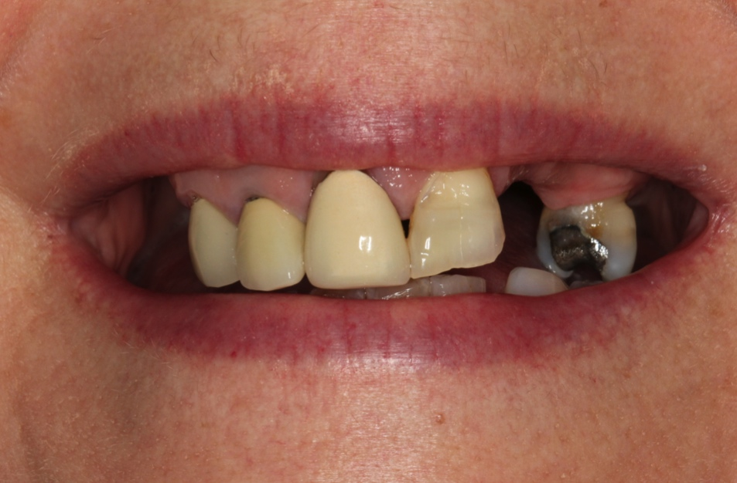

After with immediate denture
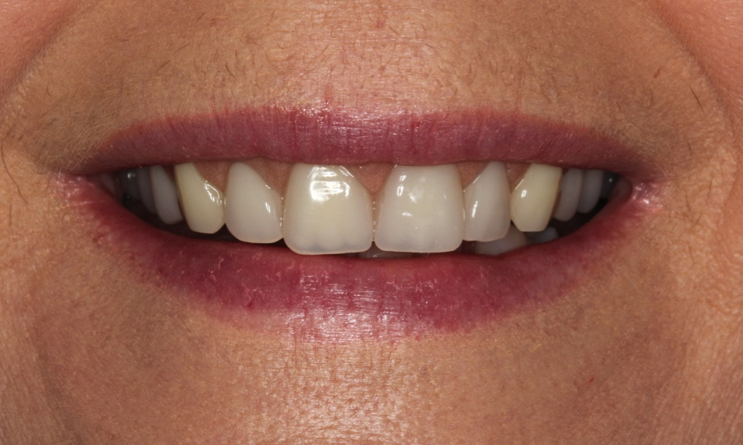

One of my patients who came over for treatment from Boston, USA:

Before (failing bridge) After with upper and lower dentures
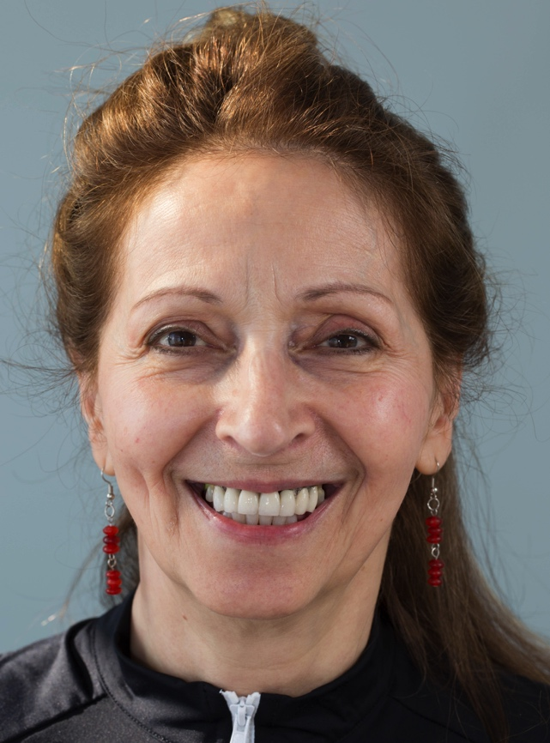

Before natural teeth After with upper and lower dentures

New upper denture - will require cobalt chromium like this to strengthen it

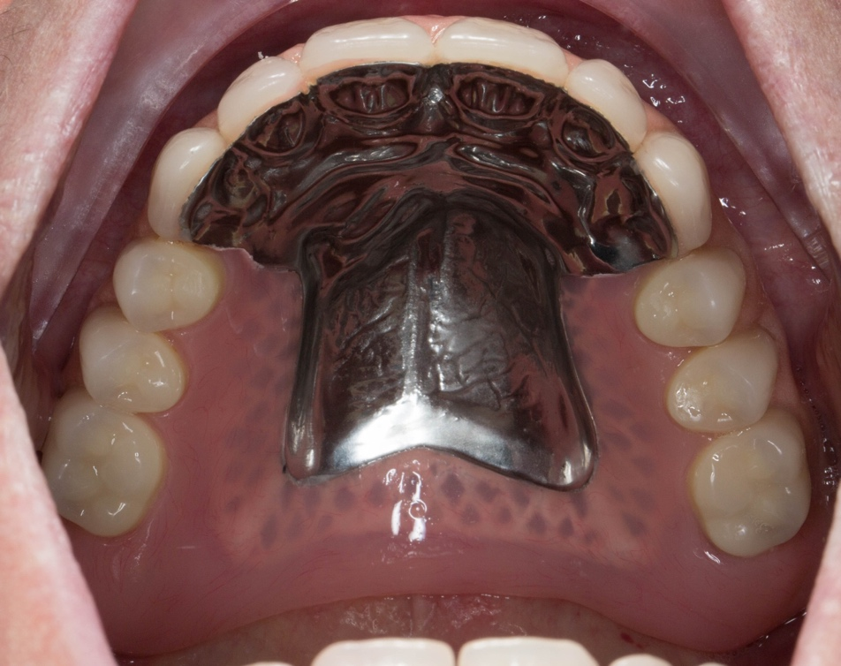

New lower denture will have metal reinforcement as a cage encased in the plastic – like this one
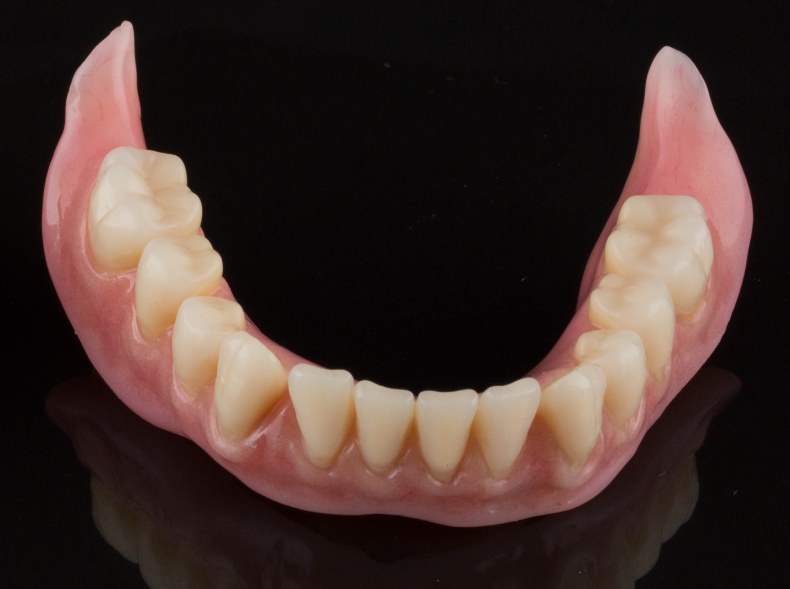

As you know, I have designed my practice around having my own in-house Dental Technologist. This means that I have complete control over the production of the laboratory work that we fabricate for our patients and is a very special part of the practice. Mr Rowan Garstang, formerly Chief Dental Technologist at the University Dental Hospital of Manchester, will fabricate the dentures. Above are examples of our work.

Replacing missing teeth (Prosthodontics) is challenging due to the two demands of function (chewing and eating) and aesthetics. The following list contains items that I feel you should be aware of before you decide to have treatment. It covers aspects of this type of treatment, which I feel are important and has been developed over the past 26 years following treating patients with similar requirements to you. I am confident that you will rapidly become aware of the care, attention and professionalism that we can provide for you.

I would like you to be aware of the following before treatment:

Immediate interim denture (before the definitive dentures are made 9 – 12 months later)
- The denture is fitted immediately fitted after extraction of the teeth. The interim denture will not fit perfectly in the areas of the extracted teeth.

- Your mouth will feel sore following extraction of the teeth for up to 2 weeks. I always recommend at least one week off work (ideally two), during this phase.

- Immediate dentures are removable mechanical substitutes for missing living tissues and as such exhibit movement when in the mouth, especially when chewing food. They are never fully satisfactory. Making the new definitive denture will be an improvement on this.

- Some patients experience difficulties with speech following the fitting of new dentures. In all of my cases, patients adapt to this and the speech normalises.

- Learning to chew satisfactorily with new dentures usually requires at least 6 - 8 weeks, and sometimes longer. New memory patterns need to be established in order for the muscles of the tongue, cheeks and lips to keep the dentures in position. These muscles need time to learn what they can and cannot do. This applies to the definitive dentures as well. This is called neuromuscular control and is the same as the adaptation required when learning to use a prosthetic hand and other replacement body parts.

- All patients with new dentures are different and experiences with new dentures cannot be compared to another person’s experiences.

- Initially the immediate dentures may cause you to produce more saliva than normal. This gradually reduces over time, but you should be aware of the change prior to commencement of treatment.

- Occasionally some of our patients require denture fixative in order to keep the dentures more secure. This is a very uncommon occurrence for my patients. This applies to the definitive dentures as well.

Definitive denture
- Careful handling and cleaning of the denture is required, because it can break if dropped onto a hard surface.

- The definitive dentures are removable mechanical substitute for missing living tissues and as such exhibit a small amount of movement when in the mouth, particularly when chewing food.

- The definitive dentures will have metal bases inside (figures above) – which will give it additional strength. This is necessary in your case as you probably grind your teeth – bruxism. The metal component plate of the denture will be slightly visible if you tip your head backwards and open wide.

- I anticipate the dentures remaining serviceable for approximately 5 years. However, because everyone’s mouth is unique I cannot be absolutely definite about this.

General
- Patients regularly ask how long their dentures will survive. Unfortunately, it is impossible to predict this accurately. As dentistry is not an exact science it is not possible to guarantee how long dental work will last. It is very important that you understand that Rowan and I plan and fabricate our work to the best possible standard we possibly can, using the highest quality materials along with our many years of training, experience and expertise. However, as with all things involving moving parts, things wear out, break, snap, crack etc. and will fail eventually. In addition, the mouth is a unique, dynamic environment in constant use. Due to variations in human biology, some people are heavier on their teeth than others which can lead to aspects of their dental work wearing, chipping or coming loose sooner than for those who are less heavy on their teeth, like you. I give a warranty on the work I provide for 1 year once active treatment has finished, where problems occurring will be rectified free of charge.

- I calculate the time and appointments required as precisely as possible. However, owing to the nature of this type of dentistry additional visits may be required as necessary. If this is the case you will not be charged for the extra visits, unless additional work over and above containing in this treatment plan is required.

- Once the work has been provided, the work is covered under a warranty for one year. After this year further treatment for items such as repairs, refurbishment and replacement are charged at my hourly rate of £425 per hour (plus laboratory fees).

- The gums/ridges shrink slowly over time meaning that the dentures may require relining and replacement over time. The fee to reline one set of dentures at my current rate is £1,600.

- I recommend that the dentures are replaced on a 5 yearly basis.

Professional fees

The investment for the provision of the above treatment, assuming it was commenced in the next 6 months is £15,100. In order for us to provide the highest quality specialist service we ask for fee settlement in one of two ways as follows:

Payment in full at appointment 1 of £15,100

or

- Spread payments of £15,100

First payment of £9,060 at appointment 1
Second Payment of £3,020 at appointment 2
Third payment of £3,020 at appointment 3

I understand that the level of investment is high. However, in order to do this treatment properly and giving you a good result requires considerable clinical and laboratory workshop time, our expertise and the use of expensive materials and components.

If you like to have this treatment, I would be very grateful if you could sign the bottom of each page and return one signed copy of this letter (keep one copy for yourself) in the SAE, acknowledging that you have read, understood and agree to the terms of this letter.

Rowan, Claire and I would all be delighted to help you achieve your wishes.

If you have any questions regarding the treatment plan, I am very happy to discuss them with you.

With kind regards

Yours sincerely

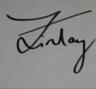

Dr Finlay Sutton

BDS, DGDP (UK), MSc, MFDS RCS Ed, MRD RCS Ed, PhD, FDS (Rest Dent) RCS Ed

General Dental Council Number: 69652

Cc X

If you would like to go ahead with the proposed treatment, I will ask you to sign a copy of this report for visit 1. By signing a copy of this report, you are confirming the following:

- That you have read the report
- That you have had the opportunity to ask and have had answered any questions about the contents of this report
- That you understand the contents of this report and agree to its terms
- That you agree to pay the treatment fees outlined in the report and at the timescales detailed in the report
- That if you do not keep an appointment without giving 24 hours advance notice, there is a fee of £250 per hour.
- That the practice reserves the right to charge for unused surgery time if more than 2 appointments are rearranged with less than 48 hours notice within a course of treatment

