Date

Dear Lynn

It has been an absolute pleasure treating you. Rowan, the team and I are absolutely delighted with the end result. You have been a fantastic patient and we have all loved treating you.

We have provided the following treatment:

Extraction of all of the remaining natural teeth

Acrylic based - immediate complete upper denture and lower implant supported dentures – spare dentures – to be taken with you if you go on holiday or away.

Cobalt chromium reinforced acrylic based - definitive complete upper denture and lower implant supported dentures to be worn routinely

The implants are:

UR4 Straumann BL 4.1 mm diameter, RC, 12mm length Ref 021.4312 Lot HG366

UR2 Straumann BLT 4.1 mm diameter, RC, 12mm length Ref 021.5312 Lot HG640

UL1 Straumann BLT 4.1 mm diameter, RC, 12mm length Ref 021.5312 Lot HG640

UL4 Straumann BLT 4.1 mm diameter, RC, 12mm length Ref 021.5312 Lot HG640

LL3 Straumann BL 4.1 mm diameter, RC, 12mm length Ref 021.4312 Lot JE402

LR3 Straumann BL 3.3 mm diameter, NC, 12mm length Ref 021.2312 Lot HF626

The implants have locator abutments on the dental implants – they are all 4mm in height.

Please keep the implant studs really clean, particularly where the implant emerges from the gum, all the way around the gold locator stud. This needs to be done thoroughly, meticulously and quite vigorously every day.

Please keep the dentures clean with denture cream and a medium toothbrush. It is advisable to use a denture-cleaning tablet such as Sterident once a week, soaking the denture for 2 hours in lukewarm water. Alternatively, very dilute Milton can be used, again for 2 hours once a week.

I would like to see you again in 12 months time for a 30 minutes review. I will then review the dentures, replace the inserts and examine the dental implants on annual basis. Please bring the spare dentures with you too.The fees for these review appointments are £250. We have a machine that cleans the dentures superbly. We will provide this at your review visits. The machine is very effective at cleaning the teeth.

Please do not hesitate to contact us if you experience any problems with the treatment we have provided. The dentures and implants are covered under a warranty for 12 months from the date of this letter.

You have been a wonderful patient, thank you once again. If you could spare the, time, I would be very grateful if you could fill in the questionnaire enclosed and return to us in the SAE regarding the improvement in your quality of life and write a testimonial letter (by email or letter) of the treatment experience you had with us. These really help prospective patients in their decision-making.

With very best wishes

Yours sincerely

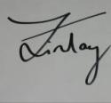

Dr Finlay Sutton

BDS, DGDP (UK), MSc, MFDS RCS Ed, MRD RCS Ed, PhD, FDS (Rest Dent) RCS Ed

Registered Specialist in Restorative Dentistry, Prosthodontics, Endodontics and Periodontics
GDC: 69652

Before After

Your natural smile which we mimicked Now

Before Now

Before
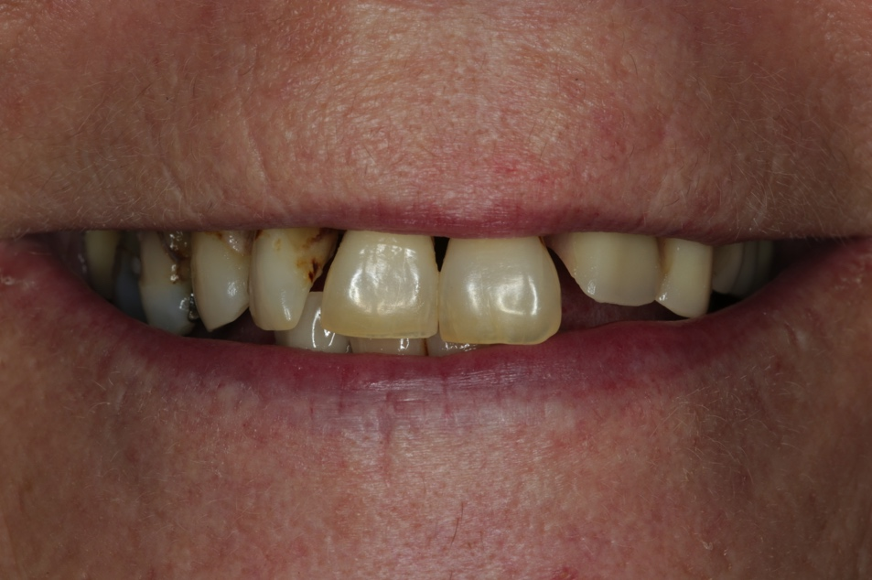

After
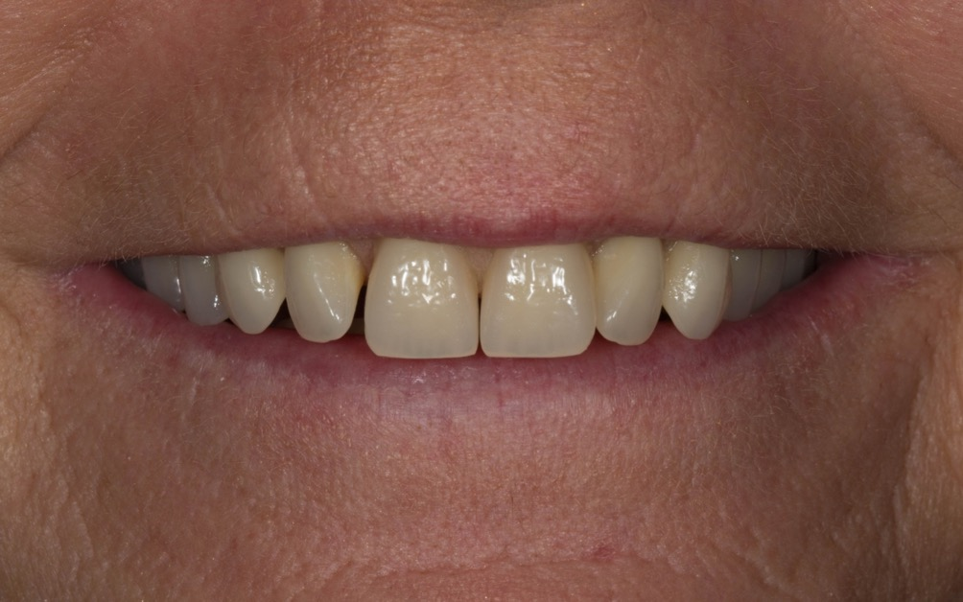

Before
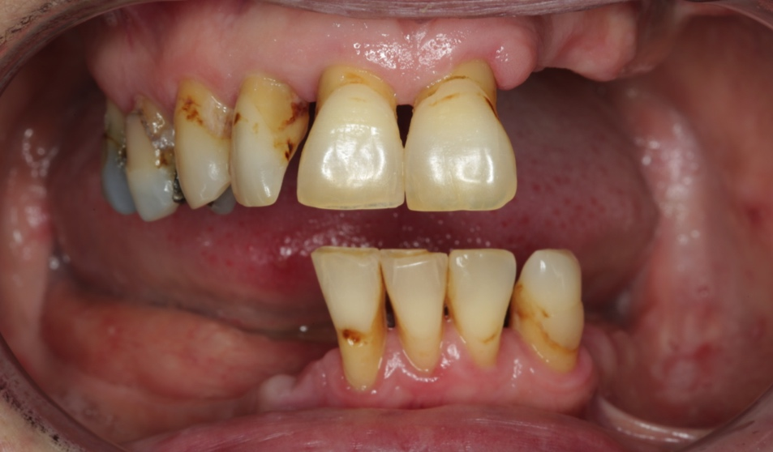

After
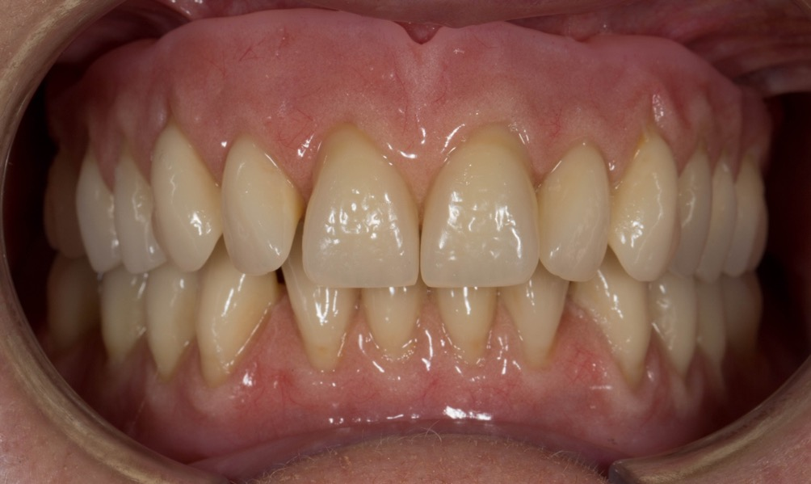

Now – upper jaw – with locator abutments and implants
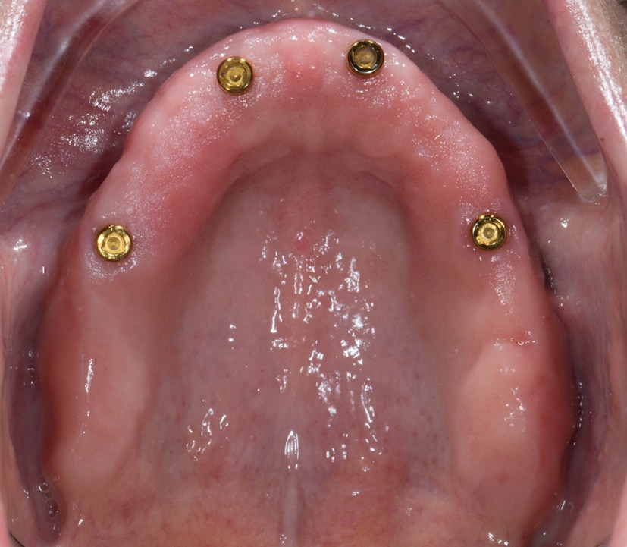

Now – lower jaw – with locator abutments and implants
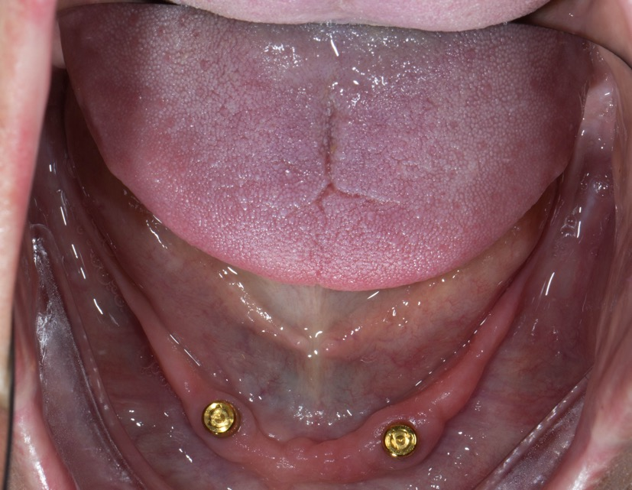

2 x upper dentures – spare and definitive
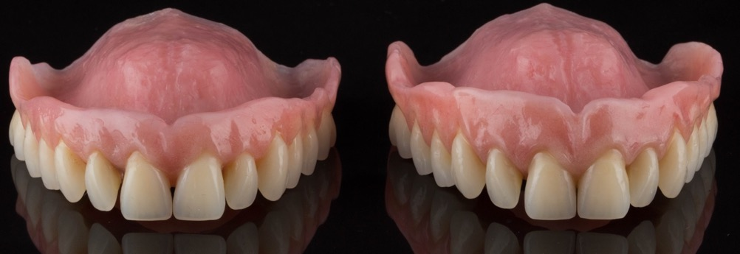

2 x lower dentures – spare and definitive
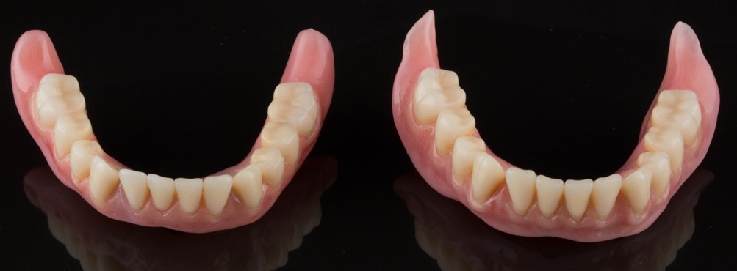

2 x upper and lower dentures – spare and definitive
