Date | Weind House  Park Hill Road  Garstang  PR3 1EL  T 01995 606091  E office@garstangdrp.co.uk  W www.garstangdrp.co.uk
Dear

It was an absolute pleasure to meet you for consultation on Wednesday 1st April 2015. Dr X has referred you to me for specialist dental treatment. Please find enclosed the diagnosis and treatment plan we discussed at the consultation.

Dental concerns:
- “Ill fitting dentures”
- “Conscious about smiling, covers mouth with hand”
- “Permanently putting adhesive in”
- “Lisping when talking”

Dental wish list:
- “Smile without crooked teeth”
- Socially, going out more and would like to smile, socialise and talk with confidence.

Diagnoses (findings):
- The remaining upper 6 teeth have large fillings and recession. They have decay around the edges of the fillings in these teeth. I am uncertain how long these teeth will last.
- The lower 4 front teeth have a small amount of decay or gum disease and are in relatively good condition. I feel that they are more of a hindrance than help in achieving a good aesthetic and functional result for you.
- The soft tissues of your mouth were visually screened for oral cancer. The soft tissues appeared healthy. This is a routine assessment we carry out for all of my patients.

We discussed these four options, in detail at your consultation, which would resolve your dental concerns, namely:
- Removal of the remaining natural teeth. Full upper and lower dentures. The advantages are that there is no need to place dental implants. The disadvantage is that the dentures are removable and will move about during function, requiring adaptation. This option would cost £11,000 and take approximately one year to perform. You did not want this option.
- Removal of the remaining natural teeth. A full upper conventional denture and a lower denture supported by dental implants on locator attachments. The advantage is that the lower denture is secured and most patients have more difficulties with the lower denture. The disadvantage is that the upper denture may move about during function. This option would cost £17,000 and take approximately one year to perform. You did not want this option.
- Removal of the remaining natural teeth. Full upper and lower dentures (which are removable) supported by dental implants on locator attachments. The advantage of this option is that the dentures are very secure and the implants remain easy to clean, with a small amount of movement. The dentures will not drop down or fall out when talking or eating. The disadvantage is that it requires surgery for the implant placement and this option is removable. This option would cost £25,000 and take approximately one year to perform. At the end of your dental consultation this is the option that you wanted. As such I have designed the plan according to this. Should you wish for this to be changed to one of the other two options, please let me know.
- Replacement upper and lower teeth, which are supported and screwed onto dental implants (not removable by you). The advantage of this of this option is that they are fixed in place. In addition, enjoyment of food is better as the palate is free. The disadvantage is that this requires tremendous diligence with cleaning underneath the bridge. This option costs £35,000 and will take approximately one year to perform. You did not want this option.
- Keep all of the remaining teeth, restore them with fillings, inlays/onlays and crowns and provide cobalt chromium based partial dentures. The advantage of this is that the remaining teeth are kept which allows a more natural feel to biting. The disadvantage is that if and when further teeth are lost the partial dentures will need to be added to. This option would cost £25,000 and take approximately 9 months perform. You did not want this option.

I am very confident we can provide an excellent functioning solution with teeth, which are effective for biting and chewing. In addition, the following treatment plan will give you attractive looking teeth, complimenting your face and smile.

Figure 1 Portrait Figure 2 on the angle

Figure 3 teeth smiling
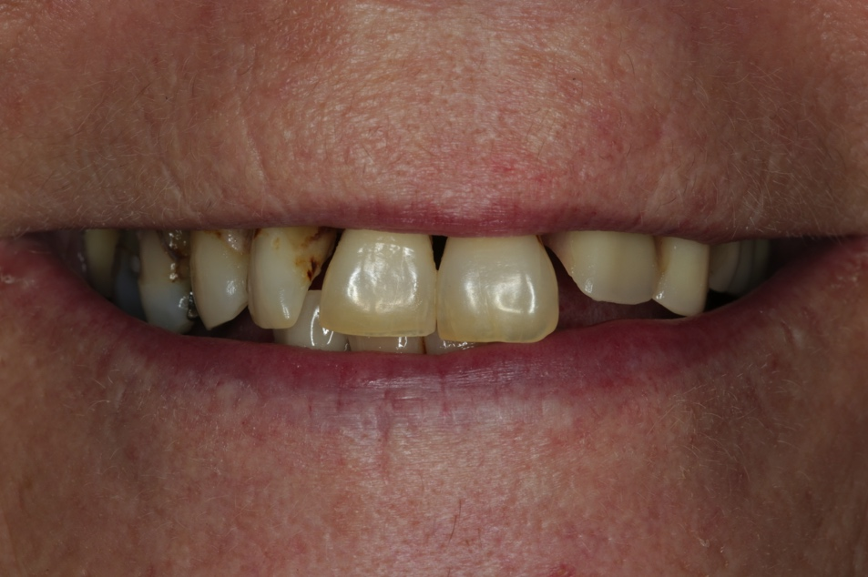
Figure 4 teeth
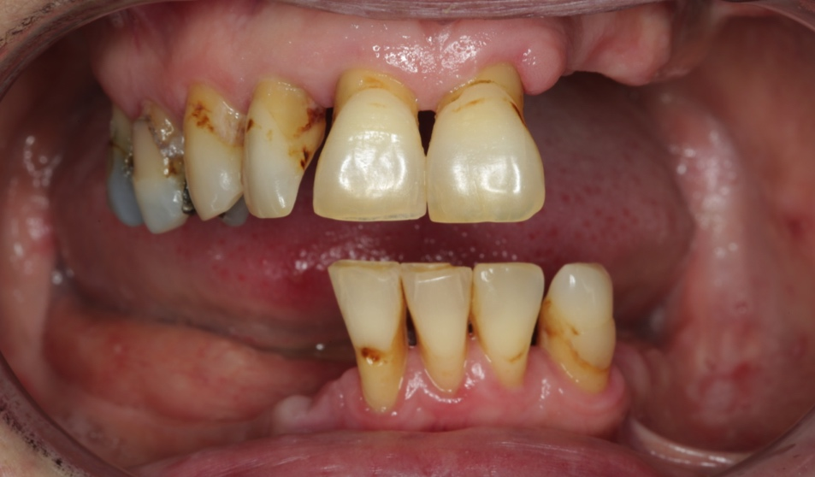

Treatment plan
In summary all of the natural teeth will be removed and replaced with complete dentures secured in place with dental implants.

In the first instance we will construct immediate (complete) dentures. The dentures will be fitted at the same time as removing the existing natural teeth and placing the dental implants. I think combining teeth removal and implant placement will be better for you and limits the time you have to wear the dentures before they are attached to the dental implants. At no stage would you walk out of the practice without teeth in place. We will place four dental implants in the upper jaw and 2 in the lower jaw (the immediate dentures will not be attached to the implants straight away). The dentures will have a natural and life-like appearance. Richard Oliver, Specialist in Oral Surgery, along with me will perform this under local anaesthetic and IV sedation. The implants would be left to integrate (take) for three months before attaching to the immediate dentures. During this 3-month time you may need to use fixative to ensure the dentures stay in place, it would be wise to limit your acting and singing to a minimum. We can discuss this fully when I see next see you at visit one. Once the dentures are attached to the implants (after the 3 months – visit 6) the upper and lower dentures will be very secure.

9 months later definitive (final) dentures (set 2) will be fabricated, this is when the gums will have remodelled to a stable position (see figures 6 - 9). The definitive dentures will have even better aesthetics, fit beautifully and will be very comfortable. The dentures will attach to the implants using locator attachments as shown in figures 5 and 6. The immediate dentures can be used as spares in case of damage or repairs being needed to the definitive ones.

Treatment plan in detail:
Visit | Treatment and result | Time required (Hours) | Time Gap | Laboratory to produce and materials to order
 | Discussion of treatment process and co-ordinating with lifestyle.  Primary imps - compo alginate | 1 ½ | 2 weeks | Immediate dentures  Drilling guides
 | Definitive impressions and jaw registration | 1 | 2 weeks
 | Try in to check bite | ½ | 2 weeks | Bio-Os implants cover screws
 | Remove all teeth and place 4 implants in maxilla and 2 in mandible  Dr Richard Oliver with Finlay  Finlay to fit dentures after surgery | Full session | 3 – 4 days ONLY
 | Review reline Viscogel etc.  More reviews as necessary  Additional visits may be required to make sure Lynn is a comfortable and happy as possible with aesthetics, speech, function etc… | 1 | 11 weeks | Order the correct height locators and more just in case
 | Expose implants fit locator abutments  Adjust the denture and process locators into the dentures at the chairside.  Imp for special tray | 4 | 1 week | Special trays over locators
 | Review | 1 | 9 months
 | Definitive impressions | 1 ½ | 2 weeks | Place locator attachments within the denture
 | Registration | 1 | 2 weeks | Try in
 | Trial insertion | ½ | 3 weeks | Co Chrome frameworks and finish dentures
 | Fit dentures – processing locator housings into the dentures | Full session | 1 week
 | Review | 1 | 1 week
 | Review | 1
Total |  | 18 | 60 weeks

Figure 5 X ray picture of your teeth with implants superimposed
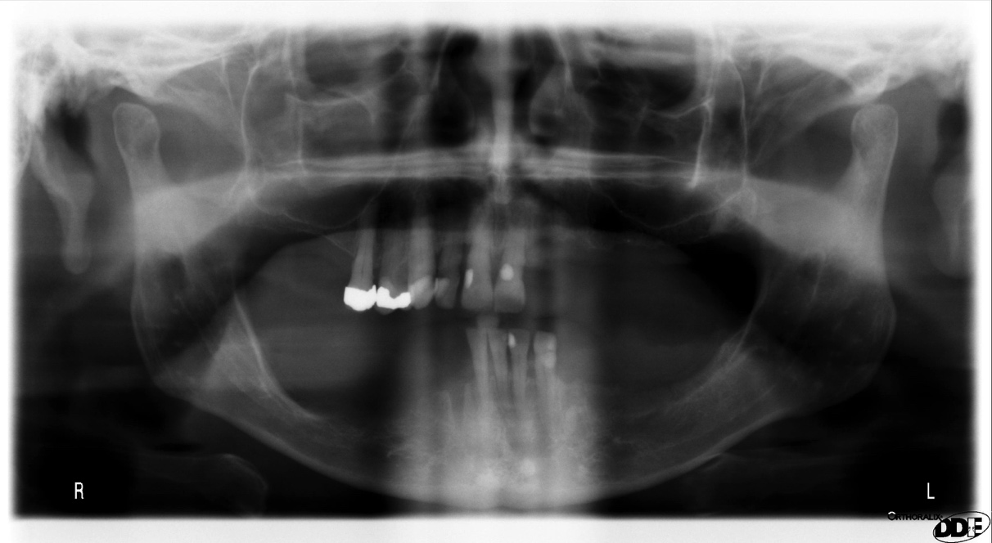
4 implants in the upper jaw – bone quality is not as good in the upper jaw, compared with the lower jaw. We therefore place more than in the lower jaw.
I recommend placing 2 implants in the lower jaw for you.

Below show photographs of my patients who have had this treatment:

Figure 6 Example of one of my patients with 4 dental implants in the upper jaw – the denture fit onto these implants making it very stable

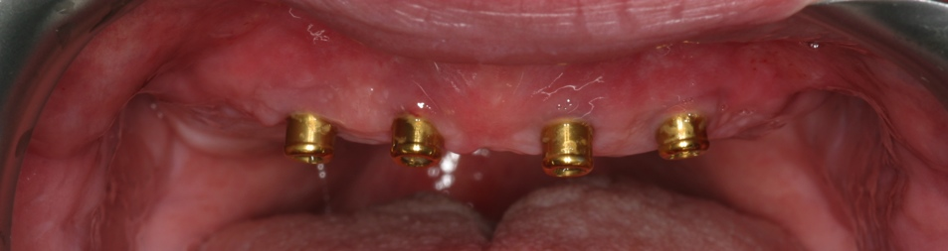

Figure 7 Upper denture with locator attachments

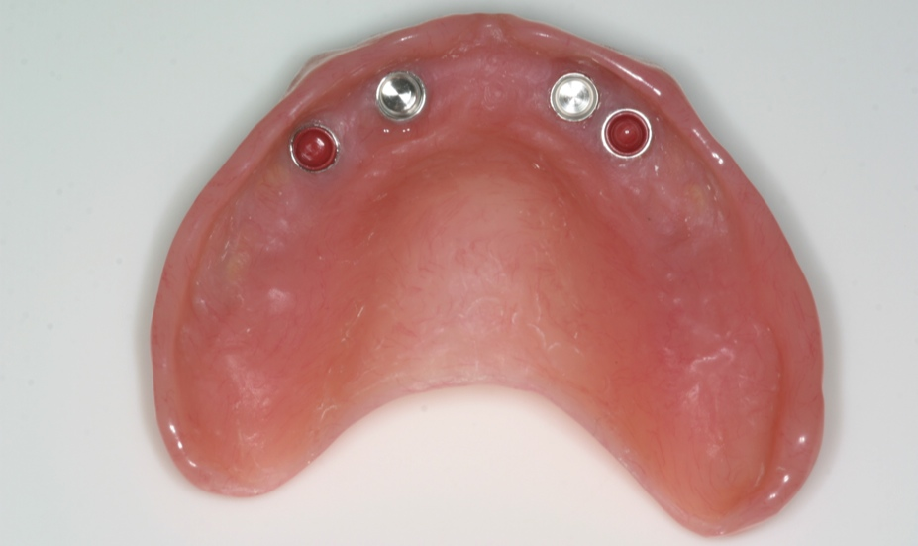
Locator attachments

Figure 8 Example of a new denture made for my patient

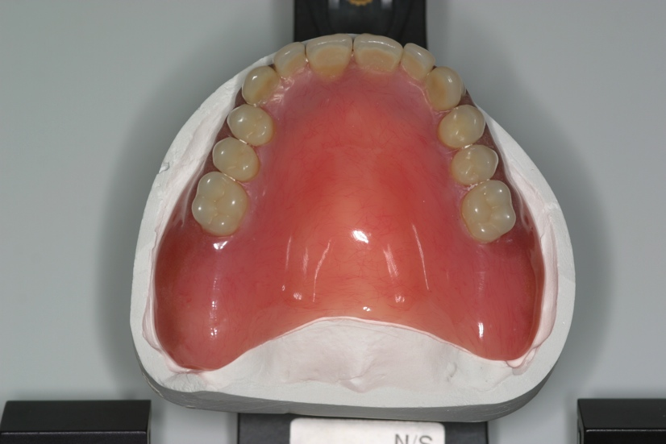
This is the amount of extension necessary for the denture

Figure 9 Before Figure 10 After

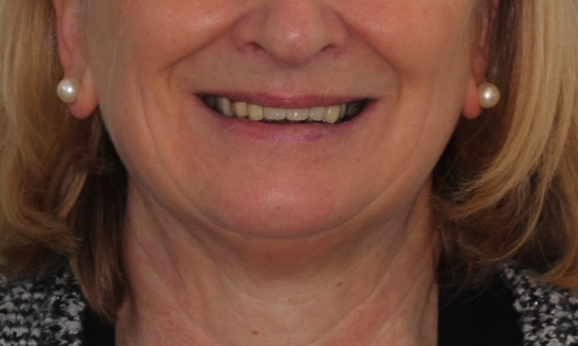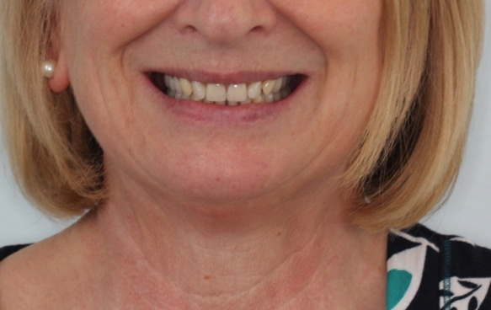

Figure 11 Before Figure 12 After
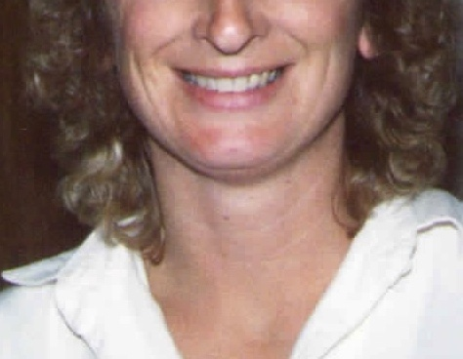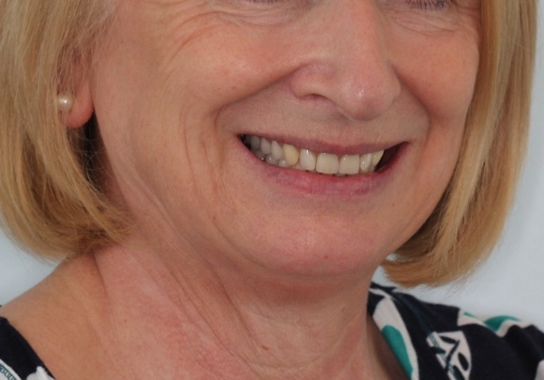

Figure 13 Before Figure 14 After
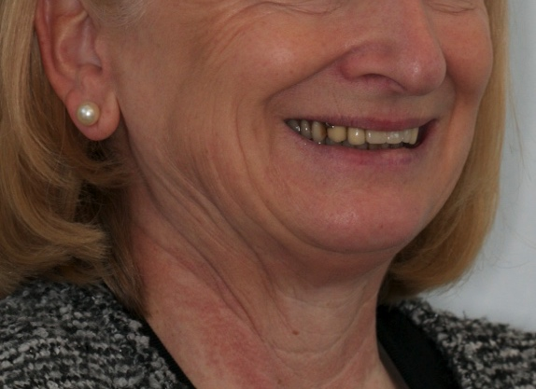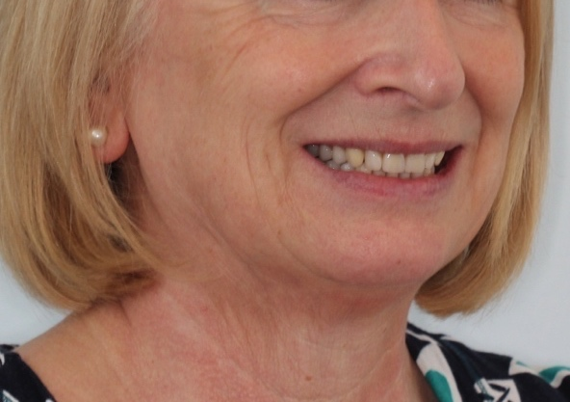

Figure 15 Before Figure 16 After
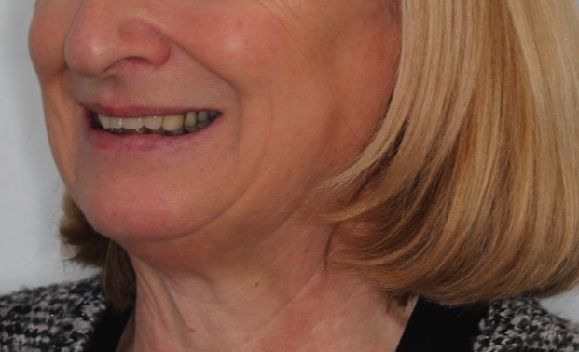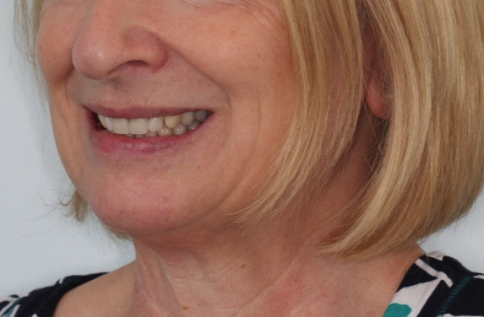

Figure 17 before above patient
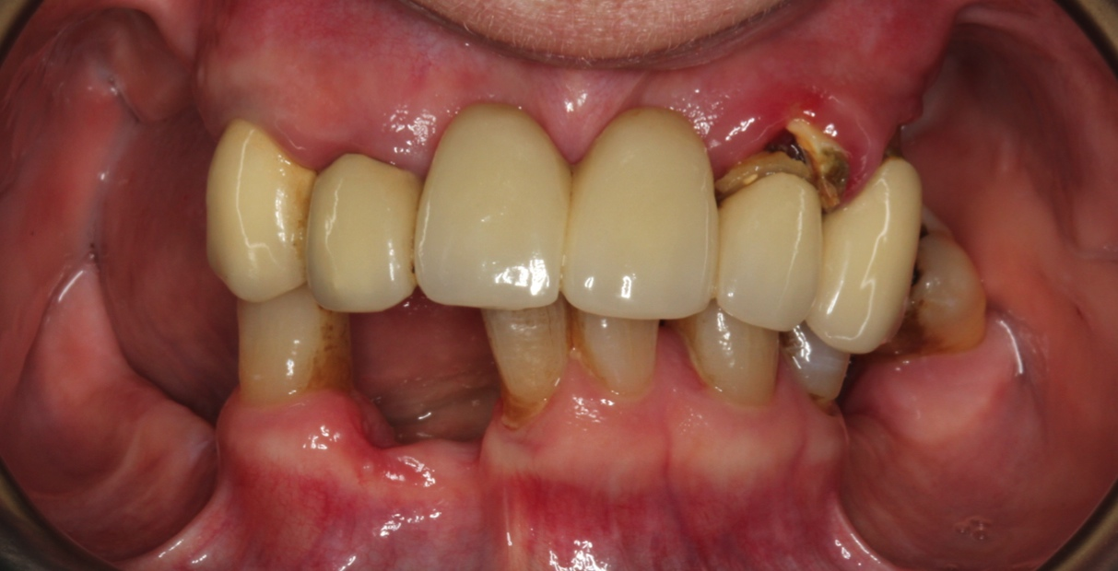

Figure 18 after above patient

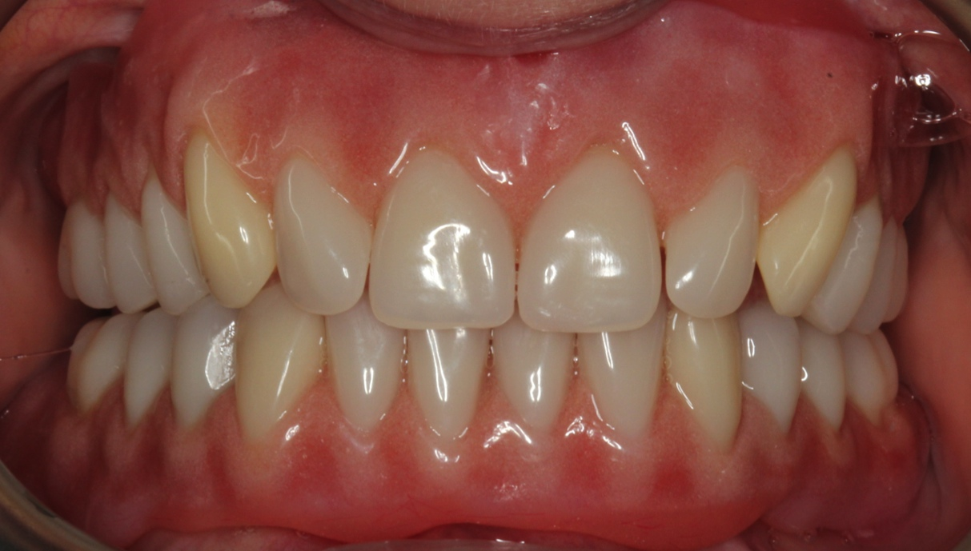

Figure 19 this is a different patient. We can make the dentures look as life like and in keeping with a patient’s age as they wish. This lady wanted teeth, which looked just like her natural teeth would at her age. They are full upper and lower dentures, with the lips retracted

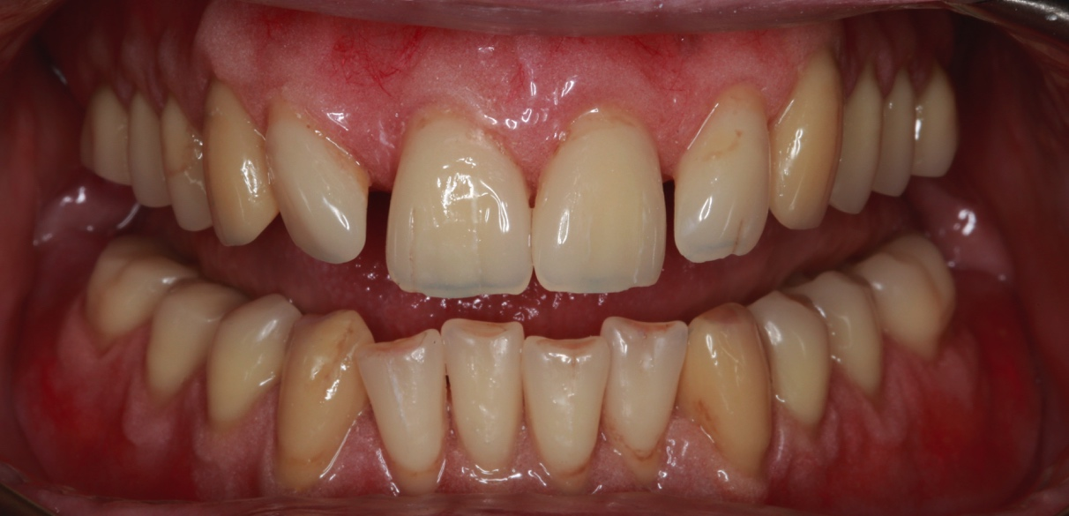

Figure 20 testimonial of a patient having the same treatment I propose for you
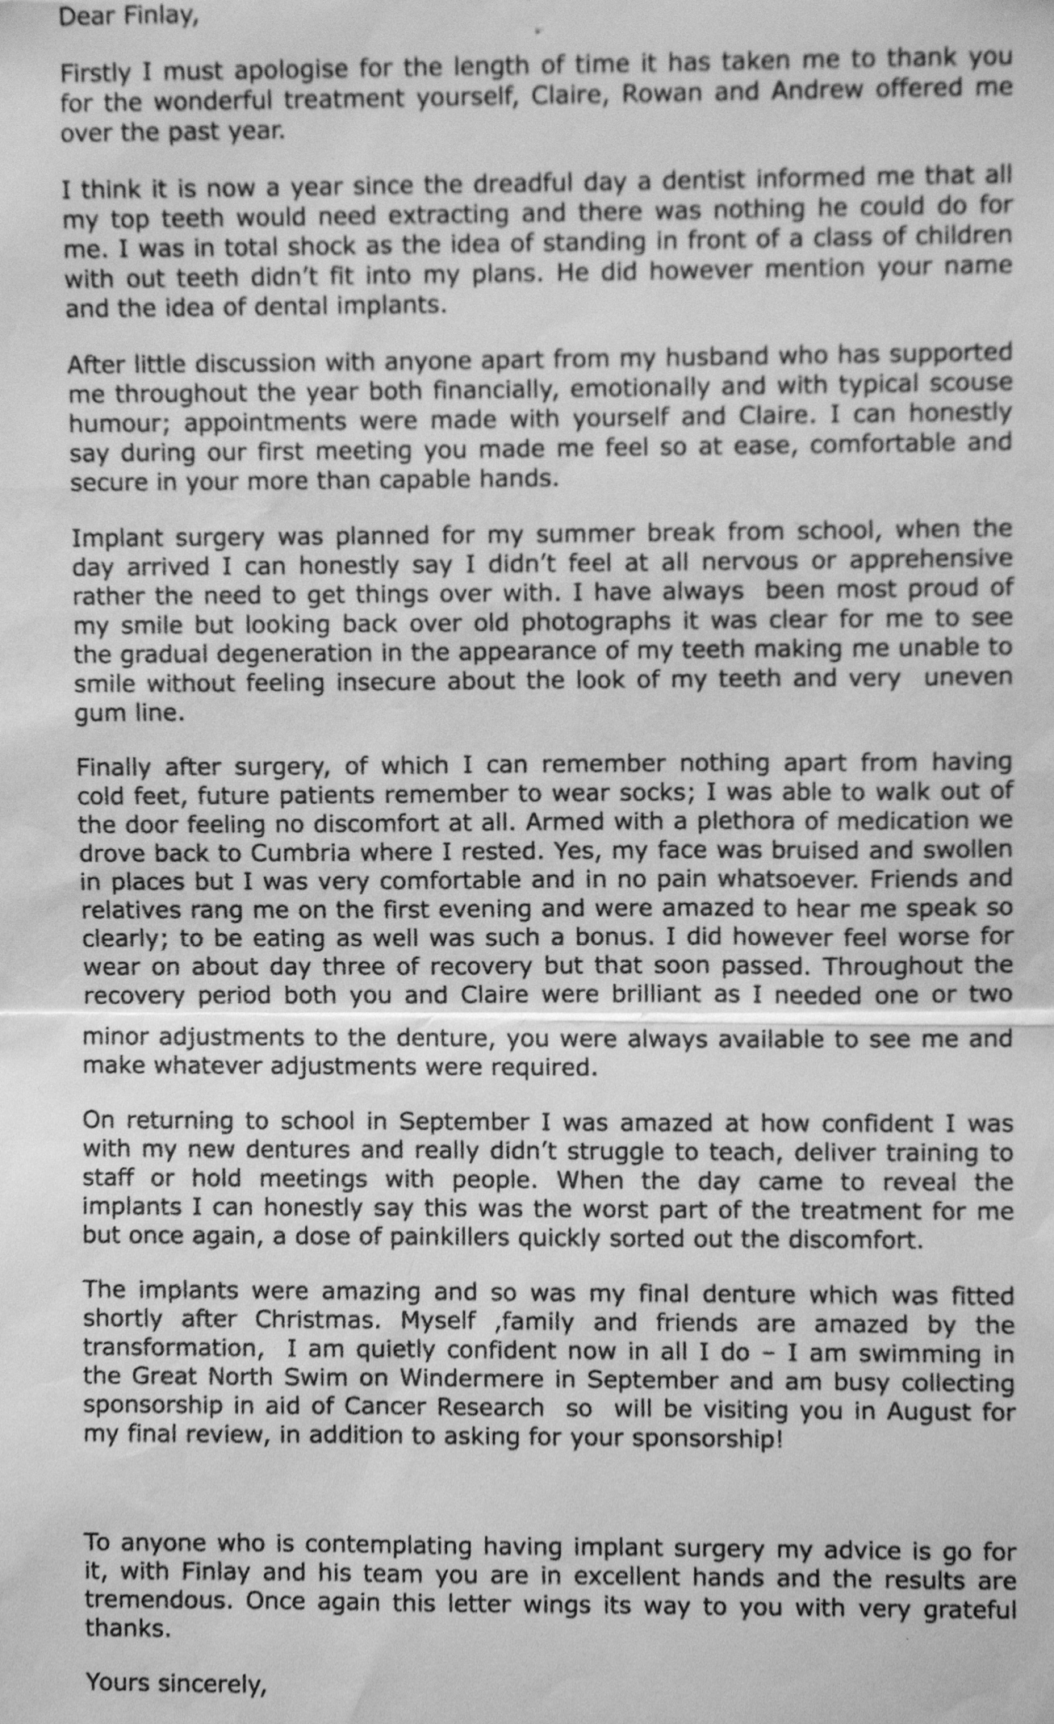

I will then review you until you are completely comfortable and happy with the treatment. This will be for as many reviews as is necessary.

As you know, I have designed my practice around having my own in-house Dental Technologist. This means that I have complete control over the production of the laboratory work that we fabricate for our patients and is a very special part of the practice. We use the finest materials available. Mr Rowan Garstang, formerly Chief Dental Technologist at the University Dental Hospital of Manchester, will fabricate all of the dentures. He is extremely skilled and talented. The above photographs show the quality of the work we can achieve.

Replacing missing teeth (Prosthodontics) is challenging due to the two demands of function (speaking, singing, chewing and eating) and aesthetics. The following list contains items that I feel you should be aware of before you decide to have treatment. It covers aspects of this type of treatment, which I feel are important and has been developed over the past 22 years following treating patients with similar requirements to you. I am confident that you will rapidly become aware of the care, attention and professionalism that we can provide for you.

You should be aware of the following:
- Please be reassured that at no stage will you leave the practice without replacement teeth.

Immediate interim dentures (before the definitive dentures are attached to the implants four months later)
- The dentures are immediately fitted after extraction of the teeth and do not attach to the implants until 3 months later. The interim dentures will not fit perfectly in the areas of the extracted teeth. This can be rectified by relining the dentures and using fixative (Polygrip).

- Immediate dentures are removable mechanical substitutes for missing living tissues and as such exhibit a small amount of movement when in the mouth, especially when chewing food. Making new definitive dentures, which attach to the implants, four months later will rectify this.

- Some patients experience slight changes with speech and singing following the fitting of new dentures. In all cases my patients adapt to this and this normalises. I understand this is a very important aspect for you. If we need to alter the dentures or remake them Rowan and I will do this until you are as happy a possible with your speech and singing, as well as aesthetically.

- Learning to chew satisfactorily with new dentures usually requires at least 6 - 8 weeks, and sometimes longer. New memory patterns must be established in order for the muscles of the tongue, cheeks and lips to keep the dentures in position. These muscles need time to learn what they should and should not do.

- All patients with new dentures are different and experiences with new dentures cannot be compared to another person’s experiences.

- Initially the immediate dentures may cause you to produce more saliva than normal. This gradually reduces over time, but you should be aware of the change prior to commencement of treatment.

Dental implants
- Placement of dental implants is a surgical procedure. The number of implants inserted will be four in the front of the upper jaw and two in the lower jaw. Placement is under local anaesthesia and supplemented by intravenous sedation by Richard Oliver, Specialist in Oral Surgery.

- Complications following surgery include amongst other things, pain, swelling, limited jaw opening, bleeding, infection, swelling and inflammation at the implant site. This is normally reported to be minimal by patients who have had the procedure. I will, of course, provide you with the necessary aftercare to minimise such effects. It is also possible in the area of the lower lip, skin, chin, gums and tongue to experience altered sensation, loss of sensation, increased sensation, numbness or tingling, which may be permanent. To place this in its correct perspective however, no patient for whom we have carried out implant surgery has experienced alteration or loss of sensation.

- Following placement of the implants, it would be necessary for somebody to accompany you home and to stay with you that night - this is always sensible following any surgical procedure.

- The gold locator abutments (figure 6), which secure the dentures, need to be kept clean with brushing with a toothbrush, on a daily basis. I will show you how to do this.

Definitive dentures (attached to the implants)
- The definitive dentures are attached to the implants via the locator attachments the denture will be very secure. The dentures will need to be removed by you for cleaning on daily basis. I will show you how to do this.

- The locator insert attachment inside the dentures will require replacement on a 12 – 18 month basis.

- Careful handling and cleaning of the dentures is required, because they can break if dropped on to a hard surface.

- I anticipate the denture and implants remaining serviceable between 5 - 10 years. However, because everyone’s mouth is unique and dentistry is not an exact science I cannot be absolutely definite about this.

General
- I calculate the time and appointments required as precisely as possible. However, owing to the nature of this type of dentistry additional visits may be required as necessary.

- Please do your best to avoid cancelling appointments. We have low numbers of patients, with very large overheads to run the practice and cancelled appointments have a considerable impact on our financial situation. If appointments are cancelled with less than 7 days notice for us to rebook we charge this at the full rate for the time unused. This is discretionary and we understand that occasionally this cannot be helped.

- As dentistry is not an exact science I cannot guarantee how long the work we provide will last. This includes the dental implants. It is very important to understand that Rowan and I fabricate everything to the best possible standard we can, using the highest quality materials and along with our expertise. However, as with all things involving moving parts, things wear out and will fail eventually. I give a warranty on the work for 1 year once active treatment has finished, where problems occurring will be rectified free of charge. I anticipate the dentures remaining serviceable between 5 - 10 years. However, because everyone’s mouth is unique and some people are heavier than others on their teeth. I cannot be absolutely definite about this.

- 6 monthly check up intervals are recommended once you have been successfully treated, with Sarah. I am happy to help at any stage should you or Sarah wish in the future. My door is always open as needed.

Professional fees

In order for us to provide the highest quality specialist service, we ask for fee settlement in one of three ways as follows:

Payment in full at appointment 1 of £25,000 (this is our preference)

- Spread payments of £25,000:

First payment of £15,000 at appointment 1
Second Payment of £5,000 at appointment 3
Third payment of £5,000 at appointment 8

- Spread payments in a loan at 0% finance over a maximum of 2 years for the balance of £25,000 (£1041.67 per month for 24 months), subject to status.

This quotation will remain valid until 2nd October 2015.

I understand that the level of investment is high. However, in order to do this treatment properly and giving you a good result requires considerable clinical and laboratory workshop time, our expertise and the use of expensive materials and components.

If you wish to proceed with the above treatment, would you kindly contact the practice. At visit one I would be grateful if you would sign the bottom of each page acknowledging that you have read, understood and agree to the terms of this letter.

If during treatment there should be any changes in your medical history, including alteration of any medication that you may be taking, would you please inform us immediately.

Please be assured that Rowan, Richard and I have the expertise and skill to help you.

With best wishes

Yours sincerely

Dr Finlay Sutton

BDS, DGDP (UK), MSc, MFDS RCS Ed, MRD RCS Ed, PhD, FDS (Rest Dent) RCS Ed

Registered Specialist in Restorative Dentistry, Prosthodontics, Endodontics and Periodontics
GDC: 69652

cc GDP

