Dear

Thank you for attending your dental consultation today accompanied by X. Dr X has referred to you to me for specialist prosthodontics (replacement of missing teeth).

Dental wishes
“To get a new plate secure in my mouth when I eat.” I can help you as part of the treatment plan below.

Diagnoses:
- The three current dentures you have can be improved on considerably in terms of fit, comfort, function and aesthetics. This is set out in the treatment plan below.
- The remaining natural upper teeth are heavily restored (have large fillings/crowns/bridge etc). However, I believe they will last many years. They are very important in securing the upper denture proposed in the plan below.
- The lower teeth are in good condition. Please continue to see X and her team to maintain these teeth.
- I think you have a relatively strong bite – bruxism. This puts the dental restorations under load and can make things wear out quickly.
- The soft tissues of your mouth were visually screened for oral cancer. The soft tissues appeared healthy. This is a routine assessment I carry out for all of my patients.

Options for replacing the missing upper teeth.

Do nothing

You did not want this.

Cobalt chromium based upper partial denture:
We discussed this as an option for replacing the missing upper teeth. Although partial dentures are not as rigid and secure in the mouth for chewing and eating compared with dental implant supported teeth, well designed and a well-made partial denture, as I propose, will improve your chewing function. This is the option that we discussed, and I felt is in your best interest and presented in the treatment plan below.

Cobalt chromium based upper partial denture retained by dental implants (removable prosthesis):
I do not believe this is necessary as you have 8 natural upper teeth remaining – which act as nature’s own dental implants to help support a denture as proposed below.

Dental implant supported fixed teeth – to replace the missing teeth (fixed prostheses):

These would be possible to provide in the upper jaw. This would involve treatment over 12 months with 20 plus visits involving bone grafts. The professional fee for this would approximately £25,000 (to replace the missing upper teeth supported by dental implants). If you wished to have this done I would be happy to provide onward referral to appropriate specialists. The main problems with this option is that this requires surgery and further visits. In addition the treatment is not totally predictable – particularly in patients who have a strong bite (bruxism).

Figure 1 Figure 2
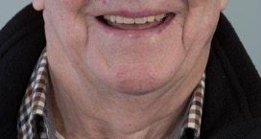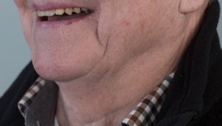

Figure 3 smiling with current upper denture in place
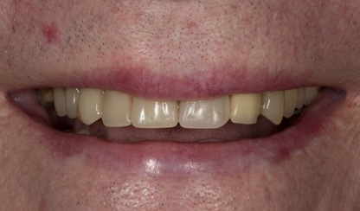

Figure 4 teeth with current upper denture in place
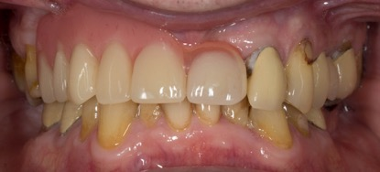

Figure 5 teeth without denture in place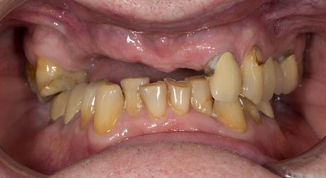

Figure 6 upper teeth with denture
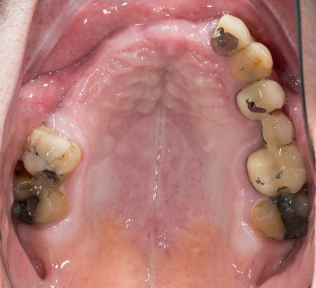

Figure 7 lower teeth
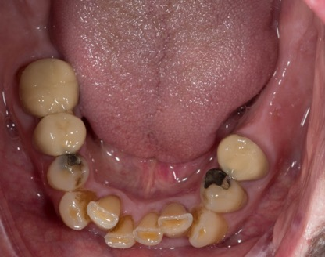

Figure 8 (a-c) X-ray picture of the upper teeth
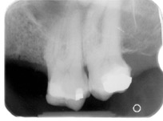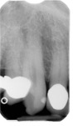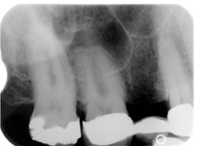

Treatment plan
Objective:
Partial denture – maxillary cobalt chromium based partial denture

Treatment plan step by step
Visit | Treatment and result
 | Primary impression
Prepare teeth
Definitive impression
 | Registration of occlusion in ICP
 | Teeth try in
 | Try in chrome frame
 | Try in chrome frame with teeth
 | Fit
 | Review

I will review you until you until you are as comfortable as possible. Occasionally this takes up to 3 review visits. This is included in the treatment plan and quotation.

As you know, I have designed my practice around having my own in-house dental technician, Rowan Garstang. This means that I have complete control over the production of the laboratory work that we fabricate for our patients and is a very special part of the practice. We use the finest materials available. I regard Rowan as one of the finest dental technicians in the UK and his work is incredible. Rowan will make the denture. Below are examples of our work in a patient with similar needs to you.

Figure 9 Design for the new denture proposed with improved design to maximise stability:, namely – palatal bar - for bracing, modification of remaining natural teeth by reshaping and addition and balancing the bite fully
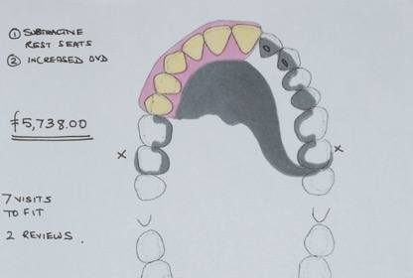

Figure 10 showing a denture similar in design to the one I propose
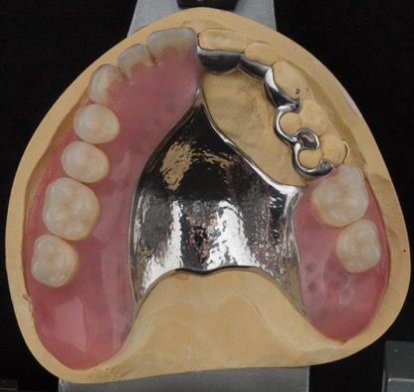

Figure 11 Without teeth similar arrangement to you
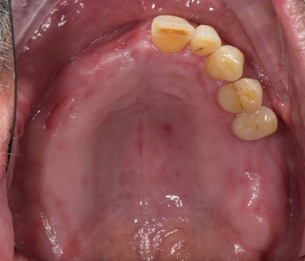

Figure 12 With teeth of similar design to you in place
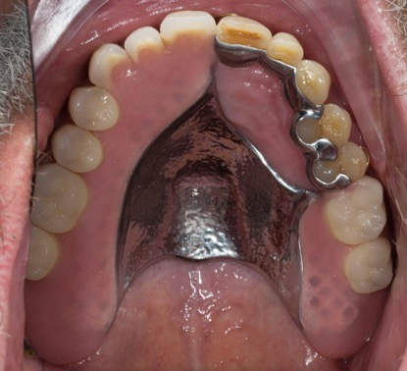

Figure 13 With teeth of similar design to you in place – please note your new denture will not have a gold clasp at the front – yours will have a tooth coloured one.
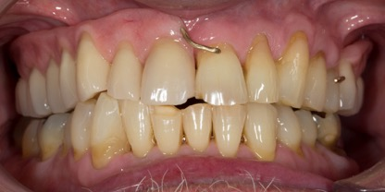

Rowan, the team and I do our absolute best to ensure that all treatment we deliver is successful. I would like you to be aware of the following regarding the treatment proposed:

It is impossible to know how long the rest of your natural teeth will survive. It is important to limit your consumption of sugar in the diet to a minimum and keep your natural upper and lower teeth meticulously clean with brushing and interdental brushes every day.

Cobalt chromium based upper denture
Dentures are removable mechanical substitutes for missing living tissues and as such will always exhibit a small amount of movement when in the mouth, mainly when chewing food and eating sticky food. I believe that with time you will adapt to this.

Careful handling and cleaning of the denture is required, because they can break if dropped on to a hard surface.

The denture will be retained by a metal clasps on the back two teeth. The clasps will not damage the teeth when the denture is taken in and out. The denture will be designed with a very specific path of insertion and withdrawal and as such the amount of “grip” required from the clasps will be minimal. I will teach you how to do take this in and out safely. These clasps and some of the metal work will be slightly visible when you smile broadly and open wide.

Some of the natural teeth will require a small amount of grinding and addition with composite, to allow the denture to sit optimally. This does not damage the teeth.

Learning to speak with dentures may take between 8 weeks and 6 months to adapt. Please note that our patients have always adapted to them and their speech normalises with time.

Learning to chew satisfactorily with a denture may take between 8 weeks and 6 months to adapt, and occasionally a little longer.

Small particles of food will find their way underneath the denture, particularly at first as you are adapting to the prosthesis.

Initially the dentures may cause you to produce more saliva than normal. This gradually reduces over time, but you should be aware of the change prior to commencement of treatment.

Rowan and I have designed the dentures in such a way that helps to protect the remaining natural teeth, so that they last for as long as possible. However, in the event that another tooth is lost, the denture will be designed in such a way that allows an addition to the denture. In the unlikely event that many of the upper natural teeth are lost in the future this may mean that the partial denture is not useable and we may need to come up with a new strategy – probably a complete upper denture.

Patients regularly ask how long their dentures and natural teeth will survive. Unfortunately, this is impossible to predict. As dentistry is not an exact science, I cannot guarantee how long the work we provide will last, as well as how long their remaining natural teeth will last. It is very important to understand that Rowan and I fabricate everything to the best possible standard we possibly can, using the highest quality materials and along with our expertise. However, as with all things involving moving parts, things wear out, break, snap, crack etc. and will fail eventually. I give a warranty on the work for 1 year once active treatment has finished, where problems occurring will be rectified free of charge. I cannot predict how long the restorations we provide will last. However, because everyone’s mouth is unique and some people are heavier than others on their teeth, I cannot be absolutely definite about this.

I have spent many years working in dental hospitals, doing further training. All of my qualifications and training have been gained with the sole purpose of giving my patients the very best treatment available. Rowan was the chief prosthodontic (head) technician at Manchester Dental Hospital for 10 years. We have both worked together and have been involved in treating patients with extremely complex restorative needs since 1999. I have designed my practice around having my own in-house dental technician. This means that I have complete control over the production of the laboratory work that we fabricate for our patients and is a very special part of the practice.

It is always at the forefront of my mind when treating my patients that they are investing considerable amounts of money having their mouths restored. As such I do my very best for everybody, using my expertise, experience and training. I treat all of my patients in a way I would like to be treated, recommending treatment, which I believe, is appropriate for each individual.

Once the work has been provided, the work is covered under a warranty for one year. After this year further treatment for items such as repairs, refurbishment and replacement are charged at my hourly rate.

Professional fees for the above plan:

The investment for this treatment is £5,738. In order for us to provide the highest quality specialist service, we ask for fee settlement in one of two ways as follows:

Payment in full at visit 1 £5,738.00

or

- Spread payments of £5,738.00

First payment of £3,442.80 at visit 1
Second Payment of £1,147.60 at visit 3
Third payment of £1,147.60 at visit 5

I understand that the level of investment is high. However, in order to do this treatment properly and giving you a good result requires considerable clinical and laboratory workshop time, our expertise and the use of expensive materials and components.

If you would like this treatment, I would be very grateful if you could kindly sign the bottom of each page acknowledging that you have read, understood and agree to the terms of this letter and return in the SAE provided.

Rowan, the team and I will be delighted to help you achieve your wishes.

Claire, my nurse has a record of the necessary visits and will organise these and manage the financial aspects. In addition, if you wish to discuss any aspect of this letter, please do not hesitate to contact me. I am very happy to answer any questions you may have over the telephone.

Yours sincerely

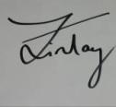

Dr Finlay Sutton

BDS, DGDP (UK), MSc, MFDS RCS Ed, MRD RCS Ed, PhD, FDS (Rest Dent) RCS Ed

Registered Specialist in Restorative Dentistry, Prosthodontics, Endodontics and Periodontics

General Dental Council Number: 69652

Cc Dr X

If you would like to go ahead with the proposed treatment, I will ask you to sign a copy of this report prior to visit 1. By signing a copy of this report, you are confirming the following:

- That you have read the report
- That you have had the opportunity to ask and have had answered any questions about the contents of this report
- That you understand the contents of this report and agree to its terms
- That you understand and agree that the specified, agreed treatments will incur costs as discussed during the consent to treatment process
- That you agree to pay the treatment fees outlined in the report and at the timescales detailed in the report
- Please note that your General Dental Practitioner will provide any additional treatment of your teeth, unless otherwise requested and I recommend you continue to see Matt and his hygiene team as normal during your treatment with me.

- Fee quotations provided in this report are valid for 6 months.

